Improving traffic flow analysis: the integration of trajectory analysis in capacity modelling.  
A case study applied to the Nord-Pas-de-Calais ECMT-Va-canals

**by**

*Adams R., Zimmerman N., Doorme S., Vandenbroucke T., Noël Chr., De Decker K., Pannemans B., Page S.[1], Thorel X., Laborie Cl.*[2]

**ABSTRACT**

In order to investigate the need and to define priorities of investments in the improvement of the traffic flow in Northern France a trajectory study and a traffic flow study are being executed for the ECMT Class Va network of Nord-Pas-the-Calais. The named Canal à Grand Gabarit links the Port of Dunkerque with the Scheldt River and its connections with the navigable waterways of Wallonia (Belgium) in a west east direction. In a south-north direction it will link the future Canal Seine Nord Europe with the Deûle-Lys river connection, and will as such provide a high performing inland waterway connection between the Seine basin (France) and the ports of the Western Scheldt and further on Rotterdam (Belgium-Netherlands). To accommodate the expected increase in traffic, potential bottlenecks will have to be identified, and improvements investigated and proposed.

The trajectory analysis allows to study the geometrical constraints to navigation, and their impact on safety, ease and fluency of the traffic on a case by case evaluation, in which the interaction between ships, or between ships and the waterway infrastructure is investigated. The required space between ships, and between ships and infrastructure can be defined for different ease, safety or fluency categories of the waterway. Such analysis will however not allow to define the viability of the waterway network to accommodate the traffic. For this purpose a traffic model is used, the latter will however be fed with the nautical intelligence of the trajectory analysis.

A desk top analysis is used to test the existing and design canals, and their ease and safety level. Sections with the lowest ease levels can as such be identified, as well as critical sections for overtaking and encountering other ships. These are the prime objectives for real time navigation simulations that are used to define the functional constraints of the different waterway sections. Viability and conditions of ship-ship and ship-infrastructure encounters can be defined through these simulation: speed, required space (length and width), possible ship (class) combination, for different equipment, flow conditions, … This information is used to both propose and investigate measures for improvement of the infrastructures or canal, or to either accept a lower functionality and impose restrictions to the navigation (e.g. reduced speed, alternating traffic …). To understand the effect of traffic fluency of such a decision, however, a traffic model is used.

A traffic model allows to build up an image of the traffic flow for a given traffic density in a given network with its given geometric characteristics. With increasing density the flow will at first increase linearly, but will reach a maximum for a specific density, after which flow decreases again, and finally comes to a standstill.

The traffic model will be used as an instrument to identify bottlenecks for the traffic flow for expected traffic after the construction of the Canal Seine Nord Europe, and to support well balanced decisions for both structural and soft measures to accommodate the expected traffic flow. It is worth to investigate whether investments in enlargement of the waterway are useful, if lock capacity remains unchanged, and whether the effort should be put in the upgrading of the lock complexes or in the bottle necks of the canal proper.

The existing traffic model IMDC Waterways (Adams et al., 2014), has been improved to include berthing times at intermediate destinations such as quays, and to take into account temporary constrictions of the fairway due to ships being (un)loaded. Speed or alternating traffic is either imposed (regulations) or calculated on the basis of ship characteristics.

The model is a so called hybrid traffic model combining theory from both microscopic as macroscopic traffic models, to allow a reduction of calculation time compared to pure microscopic models. The handling of ships is on an individual level (microscopic), checking the ship by ship. It is macroscopic in the sense that stretches with similar geometric characteristic are defined as single links characterized by the most constraining cross section. Links are defined to handle the traffic in a realistic way, without compromising calculation time. Traffic is generated based on an Erlang distribution law, which may vary in function of the traffic density at any given time (variation during the day, during the week – largely due to operating times of the locks). After a warming up period an image of the traffic is built. Allowing to evaluate the traffic capacity of the waterway network including locks, quays, ports and waterway sections. Calibration is based on known traffic flows.

Knowledge from the real time simulations of the trajectory analysis is used in the traffic model: to limit ship speed in critical sections during encounters or overtaking maneuvers, to define required space for the manoeuvers by specific ship classes, and to check whether the manoeuvers are possible or whether traffic must alternate. The insights from the traffic model flow back to the definition of measures to be investigated by the real time simulations.

The study will focus on the traffic modeling, and the interaction between the trajectory study and the traffic study.

1. **INTRODUCTION**

An increase in traffic is expected on the navigation network of Nord-Pas-de-Calais with the construction of the Canal Seine-Nord-Europe by 2023. Moreover ship size will increase, and though the network is classified as ECMT Class Va, calibration works are required to accommodate the larger vessels. Indeed the network is constructed not taking into account recent waterway design guidelines. As a consequence several bottlenecks exist for even ECMT Class Va.

A geometrical analysis was conducted to identify the bottlenecks. As the removal of the bottlenecks is costly, Voies Navigables de France (VNF) first aims at prioritizing the bottlenecks. To this end they launched two studies to analyze the consequence of the bottlenecks on safety of navigation and on the travel time.

The identification of bottlenecks is based on the geometric testing of the design against the design principles, which assume a certain ease level for navigation. In reality navigation is possible also in more constrained situations, but in which safety is still guaranteed. Moreover, encounters of other ships not always occur at these bottlenecks, implying that waiting time for encounters at bottlenecks may still be very low, and resolving the bottleneck not economically justifiable in terms of gains in ease of navigation and travel time.

Real time navigation simulations will be used to study the safety level of navigation, a traffic flow study is used to calculate travel time and to evaluate effect of bottlenecks on the travel time, secondly to evaluate whether measures are required.

1. **THE NETWORK**

**2.1 General**

The ECMT Class Va network of Nord-Pas-de-Calais, encompasses the Canal à Grand Gabarit, linking the Port of Dunkerque to the Scheldt, and the connections with the Belgian network, through the Deûle (Class Va till Lille), and then connected to the Belgian Lys through the Lys Mitoyenne, both planned for upgrading, on the one hand, and the Scheldt (Class Va till Tournai, but also being upgraded in Belgium).

This network can be considered as Class Va, corresponding to units of 110m x 11.4m and a loading capacity of 1500 to 3000 ton. Measures to bring the network to 3000 ton have been largely achieved between 1951 and 1972 with the construction of locks of 144.60m x 12m. In practice, major bottlenecks remain, because of the reduced width of the canal and the limited space in bends.

Moreover, the network is isolated from the rest of the European ECMT Class Va network as the connections with the North are either limited to ECMT Class IV, or are only partially functional as a Class Va waterway (limitations in draught, although upgrading is underway), to the south the gabarit is even more limited, only up to 800 ton (Canal du Nord), and even 650 ton (Canal de Saint-Quentin).

Therefore currently the Class Va traffic is largely limited to internal traffic on the network of Nord-Pas-de-Calais.

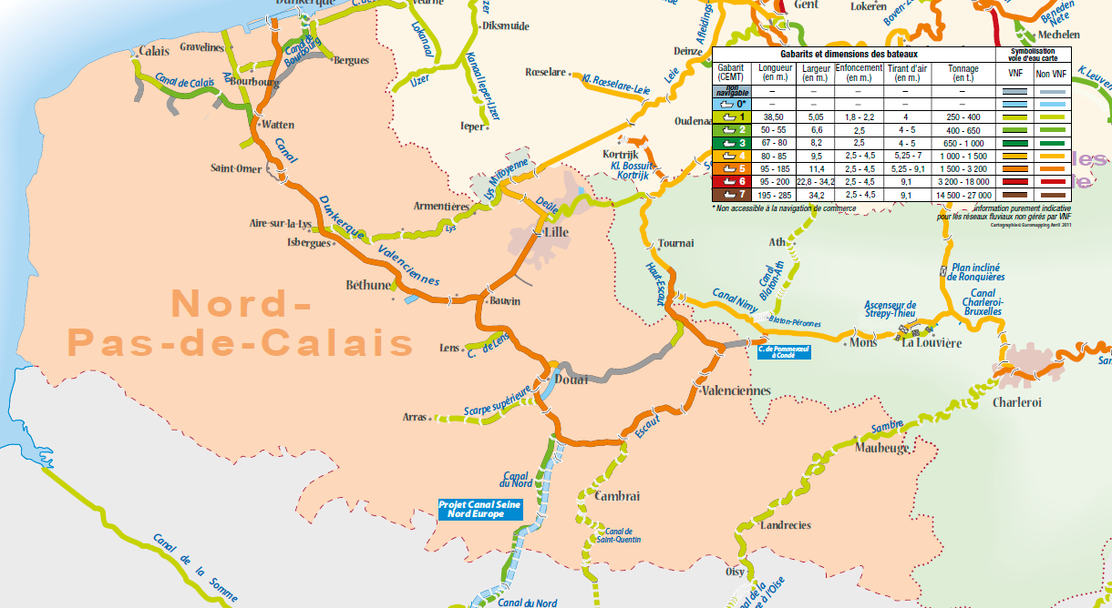**Figure 1: situation of the ECMT Class Va network of Nord-Pas-de-Calais, and connections to the north, east and south (source: VNF)**

The Class Va network of Nord-Pas-de-Calais is situated at the heart of the Seine-Scheldt liaison, defined as a priority axis of the Trans European Network. Currently several projects are conducted in France and Belgium to bring the waterways in line for establishing a network at Class Va level. To the south the Canal Seine-Nord Europe will be constructed to navigate to the Seine with push barges of 185m long. Towards the North the Deûle, Lys, and Scheldt are being calibrated to also allow push barges to the Ports of Ghent, Antwerp and further on the Netherlands. To the East the Canal Condé-Pommeroeul and the recalibration of the Scheldt-Sambre liaison will allow navigation of 110m long units to the Sambre, further on the Meuse, and finally the Rhine, Main, Danube liaison (Figure 1, Figure 2).

After implementation of these projects the Class Va network of Nord-Pas-de-Calais will be at the center of a strategic transport network linking major river and maritime ports of Western Europe with its hinterland and the continental fluvial network. The development will significantly contribute to the competitiveness of fluvial transport in the region. This will, particularly in the network of Nord-Pas the Calais, lead to following major effects: on the one hand the increase in transport volume, on the other hand the scaling towards larger vessels, at cost of the smaller, less competitive units. Whereas today’s transit and transport to the area is limited to small units, the Class V units (large Rhine ships 110m, Va, extended large Rhine ships 135m, Va+, and push barge convoys with two barges, 185m, Vb) will become more abundant in the future. The latter however need to be decoupled, as the useful length of the actual locks is limited to 144m.

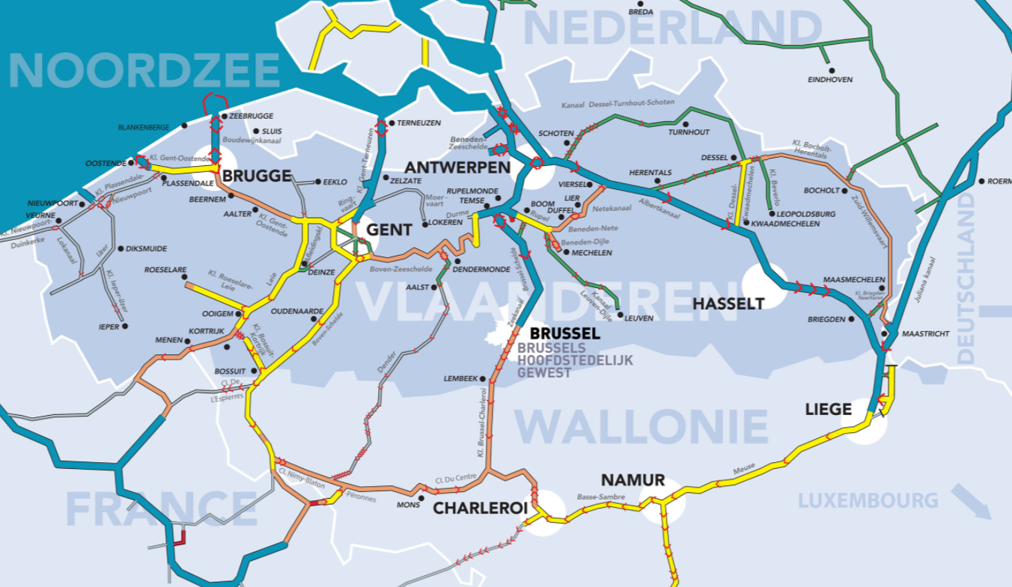

**Figure 2: Flemish interpretation of the inland navigation network (binnevaart.be)**

**2.2 Characteristics**

The current study concerns the entire class Va network of Nord-Pas-de-Calais, including the branches Dunkerque-Bauvin, Bauvin-Comines, Bauvin-Mortagne du Nord and du canal Condé-Pommeroeul. The entire network is accessible to ECMT Class Va, the Lys mitoyenne even to Vb in alternating traffic. In reality however it’s a false gabarit. The canals are old and width is limited to 30 to 34m, while 34m would be required according the guiding design principles (Circulaire 76-38). Local narrowing occurs at bridges, and no appropriate over width has been considered in bends (Figure 3). The actual accessibility was assessed in a theoretic analysis.

The network contains 16 lock complexes, the most consisting of one chamber, three consist of 2 chambers (the locks of Douai, Couchelettes, Goeulzin, of which the second chamber is sized to ECMT Class IV). The main locks are of 144.60m x 12m. The locks on the Lys Mitoyenne on the other hand are at ECMT Class Vb.

The lock of Fontinettes has an exceptionally high jump of 13m, which results in difficulties in the management of the water level and largely determines the water use.

There are 79 public quays along the network, of which half are interfering with the design waterway (distance of less than 1.6m between design waterway and a moored Class Va ship. Moreover there are 172 bridges, of which half with a narrow section, requiring speed reduction for two way traffic, and another quarter even a speed reduction for alternating traffic.

Traffic includes local transport and transit, leading to an estimated yearly throughput of about 5000000 ton in the most visited sections in 2016 (Figure 4).

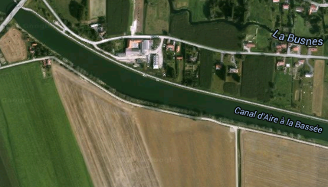

**Figure 3: example of bend with the lack of an adaquate width addition according standard design rules**

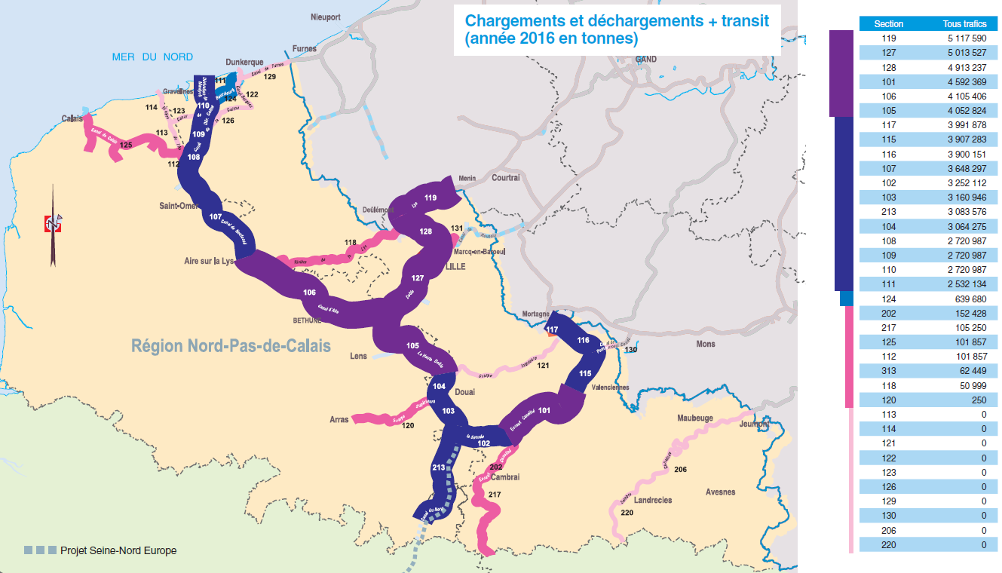**Figure 4: distribution of traffic flow on the inland navigation network of Nord-Pas-de-Calais (source: VNF)**

Fleet structure for future is expected to change, as a consequence of the scaling after the construction of the Canal Seine-Nord Europe (Table 1, number of ships at the Cuinchy lock, Stratec 2012).

**Table 1: Fleet structure for current and future traffic situations**

|  |  |  |  |  |
| --- | --- | --- | --- | --- |
| Unit | ECMT  Class | Actual (~5 Mt/y) | Traffic 10 Mt/y | Traffic 15 Mt/y |
| Freycinet | I | 27% | 23% | 11% |
| Campinois Dortmund-Ems Kanal (DEK) | II III | 27% | 31% | 25% |
| Rhein-Herne-Kanal (RHK) | IV | 31% | 25% | 25% |
| Grand rhénan | Va | 15% | 18% | 24% |
| Grand rhénan allongé | Va+ | 0% | 3% | 15% |

Vessel speed is limited to 12 km/h for empty ships, and 10 km/h for loaded ships, and is further reduced to 6 km/h in the port area of Lille and Douai. Locally alternating sections have been defined.

Trajectory studies are based on the principle that a waterway design according to the guidelines in force, in this case Circulaire 76-38, has a certain ease level (navigation speed and fuel consumption), and moreover a certain level of safety. However, beyond this level navigation may still be safe, given a reduction of speed. Although there may be some an economic loss, but navigation may still be competitive. The safety level can be defined as a condition beyond which navigation is not possible at safe conditions anymore.

**2.3 Network evaluation**

In complement of the geometric study an evaluation was carried out to check whether the network fits not only to the ease level, but also corresponds to the safety level. Beyond that level calibration measures are required. In between, navigation may still be possible in a competitive mode, if traffic allows, but should be checked with real time navigation simulations.

The safety level contains largely three reductions in regard of the ease level:

* under keel clearance(UKC)
* the over width
* the navigation rectangle (blockage factor)

In the current study, rather than identifying the section in which the design waterway does not fit the actual one, as such identifying the bottlenecks, the analysis aims at defining the level of accessibility. The evaluation is done on the basis of cross sections, bend curvature, the wet section, for three accessibility levels: two way, selective alternating traffic for unit IV, strictly alternating traffic, for both ease and safety levels, defining situations qualifying for further investigation by real time, or requiring measures (below safety level) (Table 2).

**Table 2: Accesssibility level of the Grand Gabarit network of Nord-Pas-de-Calais, as identified in the desktop study**

|  |  |  |  |  |  |  |  |  |
| --- | --- | --- | --- | --- | --- | --- | --- | --- |
| **Accessibility level** | **Va [%]** | **Va [km]** | **Va+ [%]** | **Va+ [km]** | **Va++ [%]** | **Va++ [km]** | **Vb [%]** | **Vb [km]** |
| Two way ease | 76% | 181 | 70% | 168 | 69% | 167 | 25% | 59 |
| Two way safe | 17% | 42 | 16% | 39 | 16% | 38 | 54% | 130 |
| Selective alternating ease | 1% | 2 | 3% | 7 | 3% | 8 | 2% | 5 |
| Selective alternating safe | 3% | 8 | 5% | 12 | 5% | 13 | 7% | 16 |
| Strictly alternating ease | 2% | 5 | 5% | 11 | 5% | 12 | 10% | 23 |
| Strictly alternating safety | 0% | 1 | 0% | 1 | 0% | 1 | 2% | 4 |
| Navigation impossible (incl. lock entrance) | 1% | 1 | 1% | 1 | 1% | 1 | 1% | 2 |
| **Total** | **100 %** | **240** | **100 %** | **240** | **100 %** | **240** | **100 %** | **240** |

Table 2 shows that the entire network is accessible to class Va, Va+ and Va++. The actual navigability in two ways is present on 181 km of the network, 42 other km do strictly spoken not conform to navigation in two ways, but it can be allowed if proven feasible by real time simulations.

For bend curvature, investigations are proposed for bends when the bend radius is classified as (Table 3): minimum reduced < R < minimum normal. For situations with R between minimum normal and R>10 x L, investigations are only required for higher current velocities, which do not occur in this project. If R is lower than minimum reduced measures are required.

**Table 3: bend characterisation of the network**

|  |  |  |  |  |
| --- | --- | --- | --- | --- |
| km / % of network  Bend radius | Va | Va+ | Va++ | Vb |
| R < reduced | 0km / 0% | 4km / 2% | 4km / 2% | 17km / 7% |
| reduced ≤ R < normal | 25km / 10% | 22km / 9% | 22km / 9% | 13km / 5% |
| normal ≤ R < 10*L | 87km / 36% | 114km / 48% | 115km / 48% | 134km / 56% |
| R ≥ 10 x L | 128km / 53% | 100km / 42% | 99km / 41% | 76km / 32% |
| **Total** | **240km** | **240km** | **240km** | **240km** |

For the bends, simulations are only required for Va+ and Va++ (and Vb).

The blockage factor (1/n) is investigated distinguishing between n=10 allowing high velocities with low fuel consumption, n=6 with some resistance and higher fuel consumption, but for which navigation is still a very competitive transport mode, n<3, with lower speed and high fuel consumption, which only is locally acceptable. Analysis shows n to be between 5 and 6, only locally (lock entrance, values lower than 3 are encountered. No simulations are required for this criterion.

1. **TRAFFIC**

Traffic is determined combining the lock registers to the list of voyages. The former does not contain information on the ship class, but includes the ship registration number. The voyages contain the registration number and transported load in tons. For each registered vessel the ship class was derived by attributing it to a class on the basis of the full charge (respectively 400, 650, 1000, 1500 and 3000 ton as a limit for ECMT Class I, II, III, IV and Va respectively. The resulting fleet structure corresponds well to the passages of locks as determined by Stratec (2012). A next step is the temporal distribution, hourly during the day, daily during the week, monthly during the year, of ship passages at the locks, on the basis of the lock register, showing a peak in the morning and a decline to the end of the opening hours. (Vessels outside service time pass at payment.) During the week traffic is lower on Saturday and Monday, reflecting the weekend. Throughout a month, there are no specific patterns, while throughout the year influence may be seen from peaks in coal transport (winter), grains (summer).

Distribution of loading rate is determined by dividing the load by the deadweight tonnage. Histograms show that load is generally between 60 and 100% for all units. However a relevant portion is unloaded for the larger classes. This can partially be attributed to the contribution of container traffic which does not conform to a distribution in weight categories. The amount of empty and fully loaded vessels is estimated on the basis of the lock registers, containing an estimate of the transported tonnage. In absence of a specified load the vessel can be assumed empty. The share of empty and fully loaded ships based on the lock register, can be compared to the estimated tonnage on the basis of the Origin Destination (OD) Matrices. The total transported tonnage estimated based on the lock register is systematically lower than the tonnage estimated by the Observatoire du Transport Fluvial. The latter provides the sum of both full and partial passage or entry of a section, also if they not pass the lock, while the lock register only records ships passing the locks, excluding loads that that are discharged or charged before the lock, hence the lower tonnage of the latter.

The spatial distribution shows the predominance of ECMT Class IV and Va on the Dunkerque-Bauvin Branch, and the smaller classes on the Bauvin-Mortagne Branch, which is related to the contribution of ECMT Class I by the (actual) Canal du Nord (Figure 5).

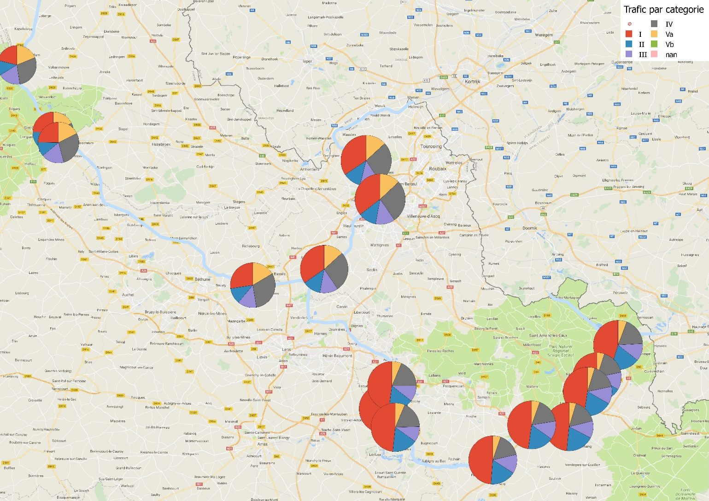**Figure 5: distribution of fleet structure in different sections of the network, showing the predominance of the smaller ship sizes in the Eastern part as a consequence of the limited gabarit of the Canal du Nord**

1. **THE TRAFFIC FLOW MODEL**

The used model is IMDC Waterway, which is a traffic flow model for inland waterways, which was presented at PIANC World Congress in 2014 (Adams et al., 2014). It is an event driven model capable of simulating branched networks. It has been further developed to also allow simulation of maritime traffic in estuarine access channels and complex ports setting such as the Western Scheldt (Delecluyse et al., 2018).

In this study it is applied to the ECMT Class Va network of Nord-Pas-de-Calais. Currently the model has been set up and calibrated for the Dunkerque-Arleux Branch, and will be expanded with the Comines-Arleux Branch (connection to the Lys), and the Mortagne-du-Nord-Arleux Branch (connection with Scheldt and Canal du Nord), to include the entire Grand Gabarit network (240km). A module for converting the model results to a web based result viewer has been created allowing the VNF to follow up progress of calibration, and to consult intermediate simulation results.

The model consists of elements of 500 to 5000m, long defining the accessibility levels as defined in the trajectory study. All lock complexes are included with defined operating times from 06h30 to 20h30 for the current situation, and 24h/24 for future traffic scenarios.

The traffic generator has been expanded to include Erlang distributions of any shape and rate (number of occurrences and duration), and is used to generate traffic at all present quays (79) and entry points of the network (4 on the extremities of the Class Va network, 6 on the branches of smaller gabarit waterways connected to the network).

Traffic is generated for current and future situations. In contrast to the current heterogeneous fleet structure (Figure 5), the future fleet structure of the macroeconomic study (Stratec 2012) is expected to be more homogeneous, as smaller ships classes will gradually disappear, and larger ships will also be able to navigate the Canal Seine Nord Europe.

The model was used to calculate current (5 Mt/y) and future traffic scenarios (10 and 15Mt/y). Although the model calculates speed using Schijf’s law, effectively taking the water displacement into account, speed is truncated using the legal speed limits.

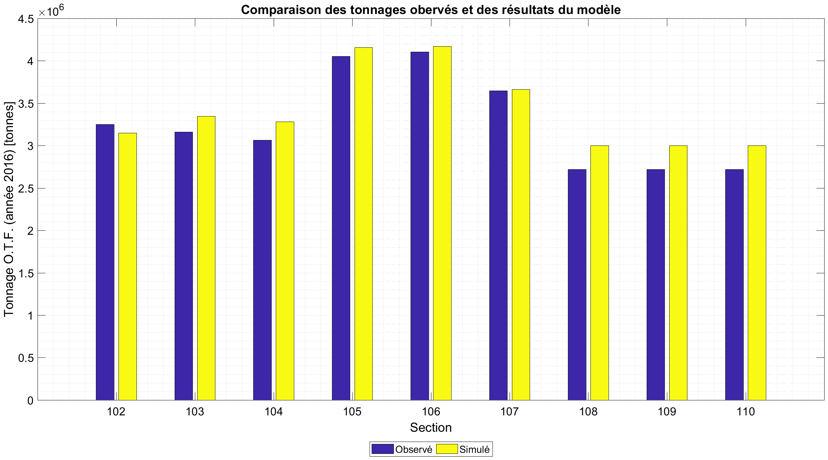

**Figure 6: calibration of the traffic flow**

For the current situation different fleet characteristics have been imposed at the level of the different OD relationships of all quays and entry points. Despite lacking information to unambiguously correlate ships with charge load, results show a good correspondence between observed (assumed) and simulated tonnage, indicating both the overall good approximation of the correlation of lock register with load statistics on the one hand (error of less than 10%), but also the simulation of the traffic distribution by the model (Figure 6). Also observed and simulated fleet composition, and temporal distribution (hourly during the day, daily during the week) correspond well, despite the obvious imperfections of the data.

Therefore, it can be concluded that both assumptions on the data and on the traffic generation can be considered reliable. Today, no accurate data are available on travel time, but the model reproduces presumed travel time (17 to 18h), indicating that the model is fit to simulate the traffic flow. The model has been used to calculate the travel time, ship encounters, study the lock operation, waiting times, number of waiting ships, lock occupancy, water consumption of the locking operation, … for both current and future situations.

A weakness in the statistics of VNF is the translation of container traffic to tonnage. Two parameters which are difficult to combine. This will become more critical for future situations as container traffic is expected to increase after commissioning the Canal Seine-Nord Europe.

First results for the Dunkerque-Arleux Branch indicate that today locks account for most of the time loss (Figure 7). Using the comfort definition for lock capacity (a maximum of 10% of the ships have waiting times of a full lock cycle), this has been reached already today at the Cuinchy and Fontinettes locks. Time loss at the multiple lock complexes is low.

After multiplying the traffic on this branch, also the Pont-Malin and Flandres locks seem to become critical. Total travel time increases with about an hour (average), but with up to 2 hours for about 10% of the ships when traffic is doubled, and even up to 10 hours for 10% of the ships when traffic increases to 300% (about 5 hours for 50% of the ships).

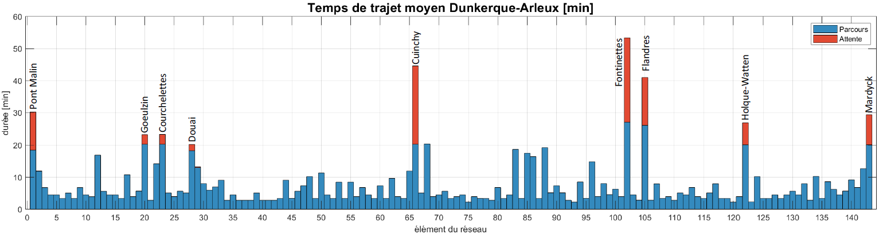

**Figure 7: calculated travel (blue) and waiting time (red) in the different model nodes**

Time loss on this branch seems to be negligible compared to the time lost at the locks. Some time loss is registered at the bend of the Marlettes bridge and the bend at the Ocre bridge. Both are reported bottlenecks in the trajectory study. They appear also here as a consequence of the combined incidence of traffic and the presence of these bottlenecks. They are also the only notable bottlenecks in future traffic situations (2 and 3x the current traffic).

Another result is the number of ships waiting at the locks. This result will be used by VNF for the dimensioning of the waiting areas, which is yet another study VNF is executing in the frame of preparing the Grand Gabarit network. The first results indicate that on the Dunkerque-Arleux Branch currently even at the most saturated lock the number of more than two waiting ships at a time is less than 10% of the time, but this increases to more than 20% of the time in Cuinchy with 2x traffic.

It is expected that water consumption increases to about 200 and 230% at Fontinettes when traffic is multiplied with 2 and 3 respectively. Today, this lock has an average consumption of about 3 m³/s. An increase of consumption is critical to the residual discharge to the Lys River, which is a main source of fresh water to the Scheldt estuary, where there is a problem of water shortage in periods of drought already today.

A protocol has been defined to study the bottle necks identified by the desktop study with real time simulations. The results of which will be used to refine the input and network definition of the traffic flow model. This will allow to redefine ship speed, particularly during encounters, and in narrow sections such as bridges and quays, to impose different rules for ships passage. The input of real ship behavior on travel time will be valuable in improving the traffic flow model.

Finally, the model will be used to study if the network is adapted to handle the expected traffic after the commissioning of the Canal Seine-Nord Europe, where it needs to be improved, and to define priorities in investments. From the first tests it appears that the locks determine the traffic flow, and will be critical to the functioning of the canal. The solution of bottlenecks may however result in transferring the bottlenecks to other locations. The traffic flow model will allow to investigate this. The hydraulic consequences also deserve a closer look: availability of water resources and the management of water levels in the canal reaches.

1. **CONCLUSIONS**

A traffic flow model has been constructed for the Dunkerque-Arleux Branch of the ECMT Class Va network of the Nord-Pas-de-Calais Region in France, and will be expanded with the other branches connecting it with the Deûle-Lys, Scheldt and Sambre-Meuse basin, and the future Canal Seine-Nord Europe, to represent the 240 km long northern French branch and ECMT Class Va connection between the Seine and Northern and Eastern European inland navigation networks.

The model has been calibrated based on traffic data from lock registers and load statistics, to produce realistic fleet structure, load statistics and travel times. The intelligence of a trajectory study of the same network is used to define the rules for ship encounters of different classes at different locations in the network. The model will be further improved using the return from real time navigation simulations, to verify calculated speed and impose speed of encounters based on tests.

The model will allow to identify bottlenecks for the traffic flow, and to confirm whether it is worth to effectively tackle nautical bottlenecks, and whether solving the bottlenecks leads to other problems with the traffic flow. The first results indicate that the locks present the major limiting factor to the traffic. Time loss in the canal, despite not being constructed using the standard design guidelines, appears to be small compared to time loss at locks, particularly when traffic is increased to the expected level after construction of the Canal Seine-Nord-Europe. The question is whether it is worth to invest in solving these bottlenecks, or possible to improve network performance in allowing higher sailing speeds. It may finally be more interesting to impose speed reductions in order to reduce damage to embankments. These situations still need to be investigated.

The expected increase in traffic clearly also puts additional stress on the availability of water resources. Pumping stations may be considered not only to reduce water consumption put also to control water levels as a result of the locking operations.

1. **REFERENCES**

Adams R., Bayart P. & Doorme S. (2014). IMDC WATERWAYS, A design tool tailored to the need of integrated design of waterway infrastructure. 33rd PIANC World Congres, San Fransisco.

Egis (2014), pour VNF Nord Pas de Calais (SMO). Etude géométrique du réseau fluvial à grand gabarit du Nord-Pas-de-Calais - Rapport de phase 1: Note de synthèse. DGAB-010-0.

1. International Marine and Dredging Consultants (IMDC), Van Immerseelstraat 66, BE2018 Antwerp, Belgium
2. Voies navigables de France (VNF), Direction territoriale Nord-Pas-de-Calais