DURME VALLEY RIVER RESTORATION PLAN. MAINTENANCE DREDGING AND REUSING THE SEDIMENT FOR NATURE RESTORATION AND IMPROVEMENT OF SAFETY AGAINST FLOODING

**by**

*Hans Quaeyhaegens, Dorien Verstraete[1], Peter Ratinckx, Toon Goormans, Roeland Adams[2], Cathy Boone[3]*

**ABSTRACT**

The Durme river is a branch of the Scheldt estuary, characterized by fresh water tidal marshes. Along the upstream part several controlled flood areas are located while in the downstream part navigation occurs. The surrounding polders drain towards the Durme during low tide. A lack of a steady upstream discharge, due to the cut-off of the upstream catchment in the town of Lokeren, and absence of regular maintenance dredging, have led to excessive siltation which has compromised these nature, flood control, navigation and drainage functions. The river restoration plan of the Durme aims at revitalizing the river functions as part of the Sigma flood protection programme, devised to protect the Scheldt estuary against storm surges. Several of these areas (Bunt, Klein Broek, Groot Broek) are located along the downstream branch of the Durme. In order to ensure the full functioning and to prevent further sedimentation at these areas, also the upstream part of the Durme river has to be restored.

The Sigma plan defines the construction of flood control areas, reduced tidal areas and areas subject to depoldering, giving space back to the river and restoring wetland and tidal nature. The construction of the dikes around all these areas requires large amounts of sand. Luckily, the sediment of the Durme generally is of sufficient quality to be used as construction material for these dikes.

The Durme Valley River Restoration Plan defines a cross section, aiming at restoring the gravitational drainage of the surrounding polders and revitalizing the silted tidal marshes. The scouring function and volume to maintain the river cross section during low tide is furthermore enhanced by the depoldering and controlled tidal action, and the restoration of the gravitational drainage of the polders, but is also supported by the construction of a pumping station at the cut-off in Lokeren.

European funding was found to reactivate the upstream flood control area ‘Potpolder IV’, which has become defunct because of the siltation. The project is a pilot in the USAR project (Using Sediment as A Resource, Interreg 2 Seas). The finer nature and higher degree of pollution provides a greater challenge in the upstream part to re-use the Durme sediment as a construction material. A special installation will be designed and used, at the construction site, to separate the fine polluted sediment from the coarser material used for construction of the dikes. Also in this area two pumping stations have been designed to allow the drainage of the catchment of the watercourse ‘Lokerenbeek’ crossing the controlled flood area.

In the meantime dredging works have been realized in the downstream section of the river, sediment stockpiles have been created to construct the dikes of the Sigma flood control areas situated in the downstream part. The pumping station in Lokeren has been constructed. The works on the upstream part are expected to start in 2018.

The Durme River Valley Restoration Plan is unique in providing and effectively realizing a restoration scheme of an entire river branch of 17 km, both revitalizing nature and flood protection function. The paper is focussing on the sediment management of the Durme River Restoration Plan.

1. **INTRODUCTION**

The tidal Durme is a branch of the Scheldt Estuary. It connects the Scheldt to the city of Lokeren. The Durme serves as drainage for the surrounding polders. In the 1960s the upstream catchment was disconnected to divert part of the discharge to the sea canal Ghent-Terneuzen as part of the necessary fresh water supply. This led to increased siltation of the tidal branch. This siltation led to a more difficult drainage of the polders, i.e. reduced gravitational drainage, which in turn increased the need of pumping stations. Other consequences of the siltation were a reduction of conveyance, and hence an increase of the flood risk in the surrounding polders, a reduced navigability, and the loss of ecologically valuable fresh water tidal marshes.

1. **THE DURME VALLEY RESTORATION PLAN AS PART OF THE SIGMA PLAN**

**2.1 The Sigma Plan**

The Sigma Plan (**Figure 1**) aims at reducing flood risk by the construction of flood control areas along the Scheldt estuary. The flood control areas are designed in such a way that they are only flooded during storm tide. The flooding occurs through overflow over the embankments, filling the available storage volume. Some of these areas have been conceived as reduced tidal areas. Via an inlet part of the tidal volume enters the area, resulting in an area subject to tide, albeit with reduced range, allowing tidal nature to develop.

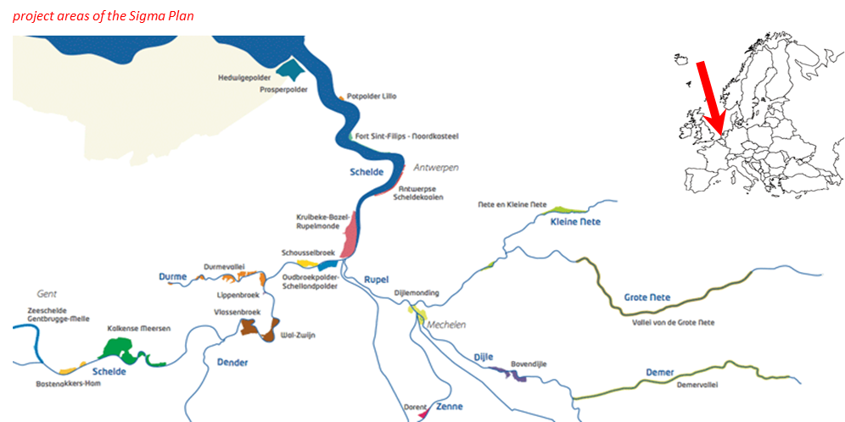 **Figure 1: Situation of the Scheldt estuary, the Durme Valley, and the different areas of the Sigma Plan**

The flood control areas are designed to protect the Scheldt estuary – hence also the Durme Valley – against flooding, taking into account the future sea level rise. It requires a strengthening and heightening of the current dikes, but also the construction of internal dikes, so-called ‘ring’ dikes, to protect the hinterland, when the flood control area is being filled by flood water. Also the depolderised areas require the construction of ring dikes to protect the hinterland. It is obvious that the protection of the estuary, and in this particular case also the Durme Valley, requires large amounts of sand, or more in general, granular material.

**2.2 The Durme River Valley Restoration Plan**

As part of the Sigma plan to protect the Scheldt estuary against flooding, and to restore ecosystem services and nature in the Scheldt estuary, the Durme River Valley Restoration Plan was developed. This includes the construction of flood control areas, depoldering and the restoration of the river channel and its functions, and rejuvenation of the estuarine nature, partially based on the revalorisation of the sediment (Adams et al. 2013, 2015).

A new cross section for the Durme (**Figure 2**) was designed to accommodate the different requirements of a well-functioning river system:

* The cross section is sufficiently wide and deep to provide the necessary conveyance for drainage of flood water, to partially restore the gravitational drainage, to increase the volume to improve the self-dredging character of the river. Moreover a pumping station was designed and constructed in Lokeren at the former connection with the upstream part of the canal. This pumping station allows flood relief of the upstream catchment, but can also be used to contribute to the sediment management by flushing the tidal Durme.
* The cross section was designed to increase the area of valuable tidal nature. The area of tidal marshes and mudflats lost through works of widening the channel, is compensated by a gain in area by the rejuvenation of the once silted areas in the upstream end.
* In the meantime the widening has to provide the necessary sediment for the purpose of constructing the flood control areas, and to protect the hinterland of the depolderised areas.



**Figure 2: Example of the cross section of the existing and new Durme, showing the increase in section area and creation of suitable surface for rejuvenation of the tidal marshes**

1. **THE DURME VALLEY RESTORATION PLAN AS A SEDIMENT MANAGEMENT PLAN**

**3.1 Sediment management within the project**

A major challenge is the polluted character of the finer sediment fractions with heavy metals (notably zinc), a consequence of the textile industry once located along the river. As the portion of fines becomes higher upstream, the sediment becomes more polluted. This fairly small grain size is another challenge, requiring separation of the finer material to make the sediment fit for construction.

The need of protection of the estuary was a major driving force behind the realisation of the Durme Valley Restoration Plan. The requirement of construction material (i.c. sediment) for protection of the Scheldt estuary is an excellent opportunity to restore the conveyance, local protection against flooding, and nature functions of the Durme. Moreover the scarcity of sediment for construction purposes in general offers an additional benefit for performing the sanitation of the river.

The Durme River Restoration Plan therefore is more than the restoration of a tidal branch, it is a key project in the Sigma plan for flood protection and nature restoration of the Scheldt estuary. However as a project on its own it basically is a sediment management project. Restoration provides the necessary sediment for the protection against flooding on a larger scale, but offers an opportunity to recreate a healthy river environment on the local scale. The sheer quantity of the involved sediment (2 million m³ of siltation between the nineteen sixties and 2010), the relatively small grain size, the impossibility to directly apply it for construction purposes, and the polluted nature, require specific approaches of sediment management that are discussed in this paper.

**3.2 Dredging techniques**

Different techniques for different phases in the dredging process have been defined for works in the Scheldt estuary (Santermans & Adams, 2015, Quaeyhaegens et al., 2017), and are also valid in the Durme (**Table 1**). Feasibility is checked with respect to the geographical and tidal constraints, however ultimately it is each contractor’s responsibility to propose the final techniques to be used and to prove the feasibility of the proposed procedure.

**Table 1: Phases of the dredging process (1-5) and available techniques (A-D)**

|  |  |  |  |  |  |
| --- | --- | --- | --- | --- | --- |
|  |  | A | B | C | D |
| 1. | Dredging | Cutter dredger | Hydraulic crane on a pontoon | Long reach | Swamp excavator |
| 2. | Transport to the treatment site | Pumping | Hopper barge | Conveyor belt | Transfer to dumpers |
| 3. | Treatment site | < 1 km | > 1 km | Slope / Terrain | Directly in dyke body |
| 4. | Improvement of chemical quality for re-use | Biological washing | Physical-chemical washing | Immobilisation | Transfer to recycling plant or dumping ground |
| 5. | Improvement of geotechnical quality for re-use | Geotubes / Geocontainers | Filter press | Lagooning | Stabilizing |

The Durme River Restoration Plan is subdivided in three distinct phases. A Downstream part, a Central Part and an Upstream Part. Each is characterised by specific geographic and tidal conditions, hence the most suitable dredging and sediment preparation techniques can differ for each.

**3.3 Treatment of the dredged material**

A flowchart (**Figure 3**) was drafted to guide the decision on whether or not the sediment along the Durme, particularly along the upper part, can be used as core material of a new dike, and, if not, what steps are required to make it suitable.

The soil samples taken from the river bed and slope of the dike along the river have been analysed based on the environmental criteria (contamination of the soil sample) and/or the geotechnical criteria (mainly the grain size distribution).

Uncontaminated dredged material determined will be assessed based on geotechnical criteria (grain size criteria). The coarse-grained material taken from the river bed and/or the slope of the existing dike can be directly re-used as core material for the new ring dike.

The fine-grained material (small fractions (I+II) higher than 10%) is assessed based on the plasticity index criteria and/or UK-ADAS texture triangle. Material classified as fine sand or silty to clayey sand can be directly re-used as core material in the new dike.

Other sediments (sandy loam, silty loam …) require treatment to reach criteria for workability and geotechnical stabilisation. The treatment exists in dewatering of the material or using additives. Once the material has been treated, the sediments can be used as core material.

The exceedance of acceptable Zn, total PCB, Cd, Cr III, Cu, Benzo(a)pyreen and mineral oil concentrations for free use of dredged material (Flemish legislation: VLAREBO Annex V) is a first step of the assessment of treatment requirements. Treatment of the material aims at obtaining the VLAREMA certificate for the use as secondary raw material, based on the allowed total concentrations of heavy metals and a various number of organic compounds and on the leachability criteria for heavy metals. If one of the criteria is exceeded an on- or off-site treatment of the material can be considered to finally make a re-use possible. A mobile treatment plant is considered for obtaining the VLAREMA certificate, as off-site treatment may not be economically feasible. This requires an adapted dredging strategy.

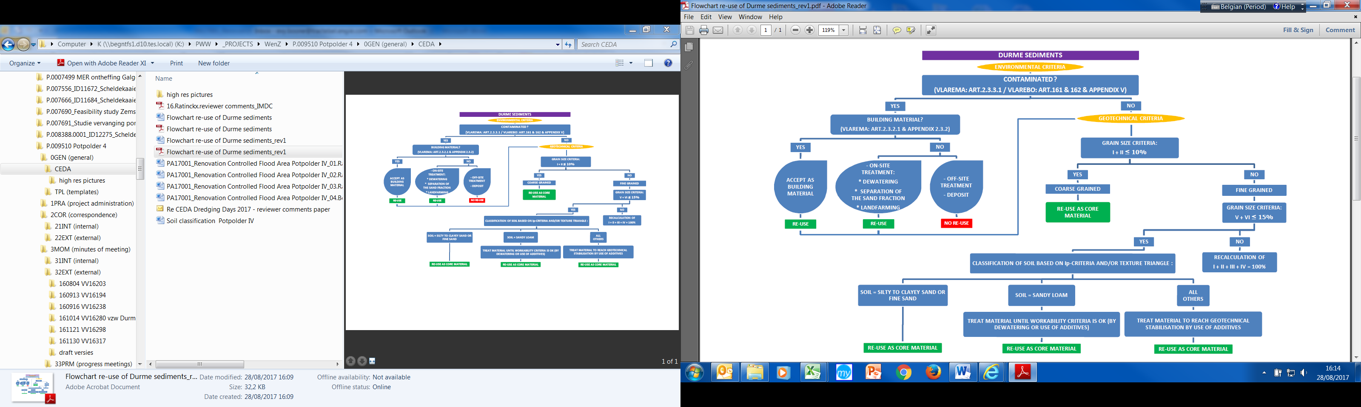

**Figure 3: Dredged sediment re-use decision flowchart**

1. 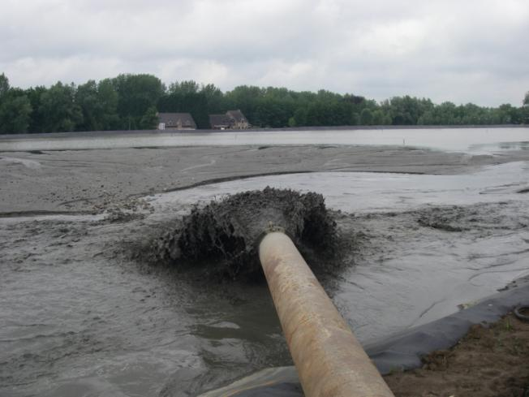**THE DOWNSTREAM AND CENTRAL PART OF THE DURME**

The downstream part of the Durme is the widest, and still navigable today. Dredging started in this area. Cutter suction dredgers were used for dredging the design profile, the sludge being led to basins for lagooning. These basins were realized by constructing the dikes for one of the areas for future depolderisation (**Figure 4**). In the lagooning basin, the coarse material on the one hand settles near the outlet of the pipeline transporting the dredged material. On the other hand the fines reach the far extremity of the basin, allowing to separate the finer material from the sand used for construction.

**Figure 4: outlet of pipeline in lagoonation area (temporary sand stock) along the Durme**

The fines are removed for processing in disposal areas or sanitation. The sand constitutes a temporary stock for future construction of the Sigma dikes, in both the flood control areas and depolderised areas (Bunt, Groot Broek and Klein Broek).

The central part of the Durme is much narrower, but still wide enough to be accessible for a pontoon, especially after the dredging of the downstream part. Dredging occurred with a hydraulic crane on a pontoon (**Figure 5**), leaving enough space for a barge to be filled for transport to a temporary sand stock for the construction of the Vlassenbroek flood control area, some 10 km upstream from the Durme mouth along the Scheldt river.

The project of the downstream and central part of the Durme Valley River Restoration Plan included the design and execution of the dredging works, and the lay-out of temporary sand stocks for future dike construction.

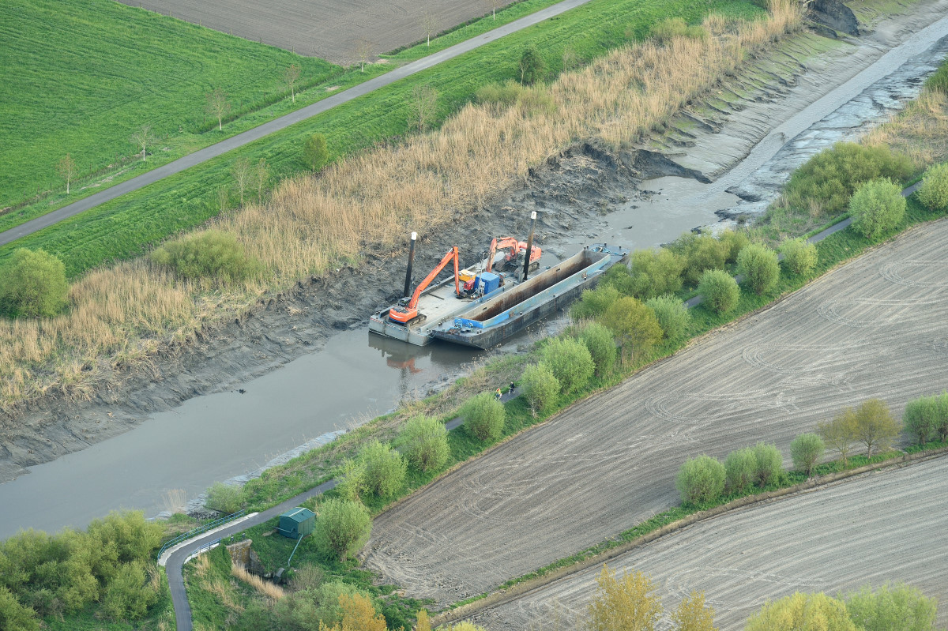

**Figure 5: Hydraulic crane on a pontoon, with a barge, during low tide – Central part of the Durme**

1. **THE UPPER PART OF THE DURME**

**5.1 Restoration of the flood control area ‘Potpolder IV’**

The sediment recovered in the upstream part will be used for restoring the flood control area ‘Potpolder IV’ (**Figure 6**). Potpolder IV has been serving as flood plain for the Durme river since the nineteen forties. However, the dikes around the flood plain no longer comply with the actual safety levels for flood protection as defined in the Sigma plan. Dredged material from the Durme river will be used as building material for the construction of new embankments. The project is a pilot within the Interreg 2 Seas programme USAR “Using Sediments as A Resource”. The project covers the complete design of a new ring dike and the adaptation of the existing dikes along the Durme river to an overflow dike in order to realize a flood control area. Dredged material has been examined and treatment techniques have been proposed to be able to re-use all the material within the new dikes, including contaminated material, in accordance with all environmental regulations. Treatment techniques include dewatering and separation of the fine fraction, stabilization techniques in order to obtain better geotechnical characteristics or the use of geobags or geocontainers in the core of the dikes. The design as well includes all required works to the watercourses in the area, as well as the construction of two new pumping stations. Works are planned to start in 2018.

The flood control area ’Potpolder IV’ was initially designed in 1938 and dikes around the area were built in the 1940s and 1950s. Actual crest levels vary between +5,1 and +5,7 m TAW (TAW = the Belgian reference level).

The main purpose of the project is the restoration of the flood control area according to the actual standards by building a new ring dike with a crest level of +8,0 m TAW to prevent flooding beyond the flood area limits, and adapting the existing dike along the Durme to an overflow dike (weir) with a crest level below +6,8 m TAW, in order to obtain efficient filling of the area and an overflow frequency of at least once a year (determined by numerical hydrodynamic modelling). Overall perspective is a better protection of the valley against uncontrolled flooding and lowering the maximum water levels in the upstream part of the Durme river.

Today the actual crest level of the dike along the Durme fluctuates due to the deposition of sediment, causing uncontrolled overflow. The project aims at moving to a controlled regime with an anticipated overflow frequency and controlled flooding and emptying durations. By lowering the crest level and increasing the length of the overflow dike the top of the tidal wave passing through the Durme river can be “captured” and a maximum water level imposed to the river. This way an artificial boundary condition is set for the upstream river stretch and water levels are controlled in a better way. Rainfall runoff conveyed by the local watercourse ‘Lokerenbeek’ is stored in the flood control area during incoming tides, whereas it is emptied during low tide periods.

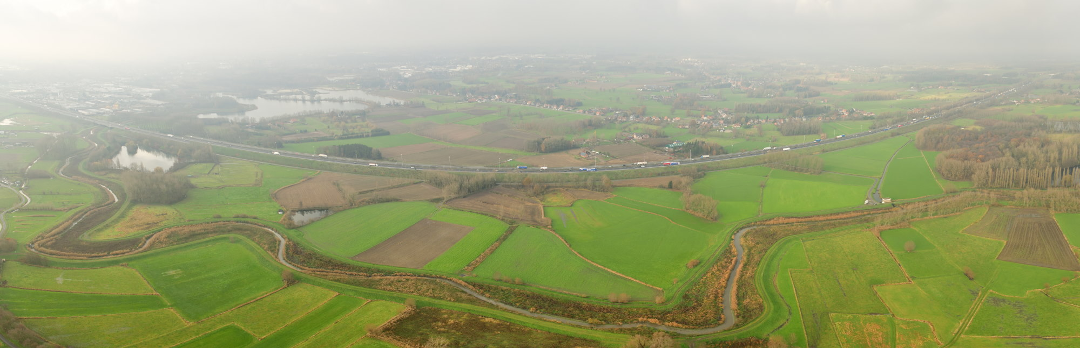 **Figure 6: The targeted area for restoration of the flood control area ‘Potpolder IV’ is enclosed between the motorway E17 and the Durme**

The project includes the construction of two pumping stations, to allow the drainage of the area upstream the flood control area, and the emptying of the area after flooding of the flood control area.

This discussion will however focus on the investigation whether and how the dredged material resulting from the maintenance works in the upper part of the Durme river can be used within the body of the new ring dike.

**5.2 Project characteristics**

Dredging in the upstream part of the valley to provide material for use in the new ring dike concerns a volume of around 260 000 m³. The river stretch to be dredged is about 8 km long and is situated between the weir in Lokeren (upstream) and Waasmunster bridge (downstream).

Due to the restricted dimensions of the river and the tidal process limiting the water depth in periods of low tide, the use of a cutter dredger or a pontoon with hydraulic crane is not possible. The accessibility and stability of the existing dikes along the Durme, makes a long reach crane or swamp excavator viable options, the first having the advantage of working outside the actual river bed, the latter being able to be operational in the mud flats but not operational in the river bed at high tide. The choice will also largely depend on the transport facilities from the dredging location to the treatment site.

Transport techniques are a function of distance between dredging and treatment location and the proximity of residential areas. Even if the flood control area is situated more or less in the middle of the (upper) Durme valley, transport distances are large and transport along the winding river bed and dike will be difficult. It is therefore uncertain that pumping techniques may be a feasible solution. The use of hopper barges is excluded due to insufficient river bed dimensions and water depth. Conveyor belts are only feasible in combination with a mechanical dredging (or dewatering) technique but due to the same constraints as mentioned before not an option in this case, leaving only the option to directly transfer to dumpers.

The temporary treatment site will most likely be organized in the flood control area. As treatment will be part of the contractor's responsibility it cannot be excluded that smaller intermediate treatments and/or dewatering sites are set up as well.

Whereas dredged sediments are usually dehydrated by means of lagooning or natural dewatering, techniques that need time and space, De Vlaamse Waterweg aims at finding a technique of “immediate” re-use without intermediate storage for dewatering.

**5.3 Sediment evaluation**

One of the most important dredging and structural parameters of the sediment with respect to re-use and evaluation of possible treatment procedures is the fines fraction or the content of particles smaller than 63 µm. Between Lokeren (upstream) and Waasmunster (downstream) the fraction of fines varies from 80% to 15% with an average of 45%, with an increase of fines in the river bed from downstream to upstream with a d50 of around 50 µm (silt) to 90 µm (fine sand) (**Figure 7**).

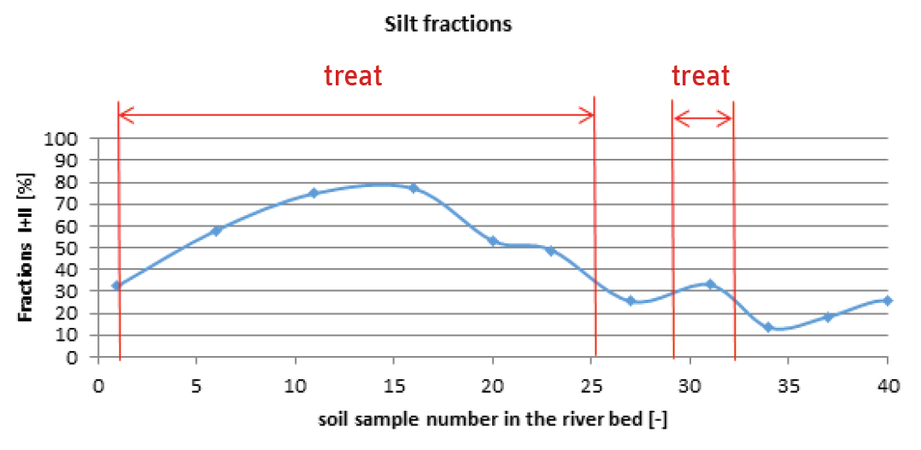

**Figure 7: Determination of sediment for treatment, samples 1 to 40 from upstream to downstream**

Classification of typical soil samples is shown in **Figure 8**. These classifications will lead to the determination of treatment techniques to be applied in order to make the material appropriate for re-use. Dredged material from locations as classified in the left figure are suitable for immediate re-use in the core of a new dike, whereas dredged material from locations as classified in the right figure require treatment before re-use.

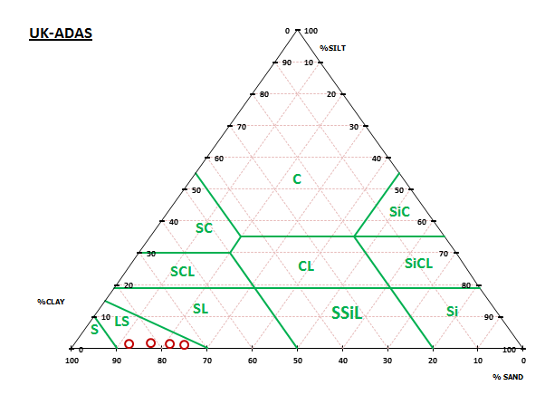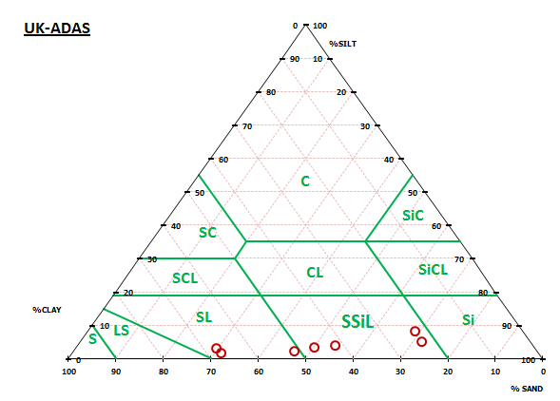

**Figure 8: Classification of soil samples in the Durme river bed based on the UK-ADAS textural triangle**

The samples were additionally tested for environmental quality characteristics to determine whether the sediment can be used as building material or as secondary raw material. Flemish legislation (VLAREMA, Flemish regulation on sustainable management of material cycles and waste products) defines “building material” as any material which is used within infrastructural works. Material that is contaminated in any way is defined as “waste material”. Some specific waste material may switch from the classification ‘waste’ to ‘building material’ after treatment to be used for certain applications as recycling or re-use, and if they meet specific criteria:

* The material is used for a specific purpose;
* There is a (market) demand for the material;
* The material meets the technical requirements for the purpose and the concerning legislation and standards;
* The use of the material has no negative impact on the environment whatsoever.

**Figure 9** compares the quality standards, green being acceptable as building material, red meaning there is exceedance of certain parameters making the sediment unsuitable for direct re-use. An additional distinction was made between sediment from the river bed and sediment from the bank slopes. It is clear from the figure below that a large volume of dredged material is unsuitable as building material without treatment for re-use in the new dike cores.

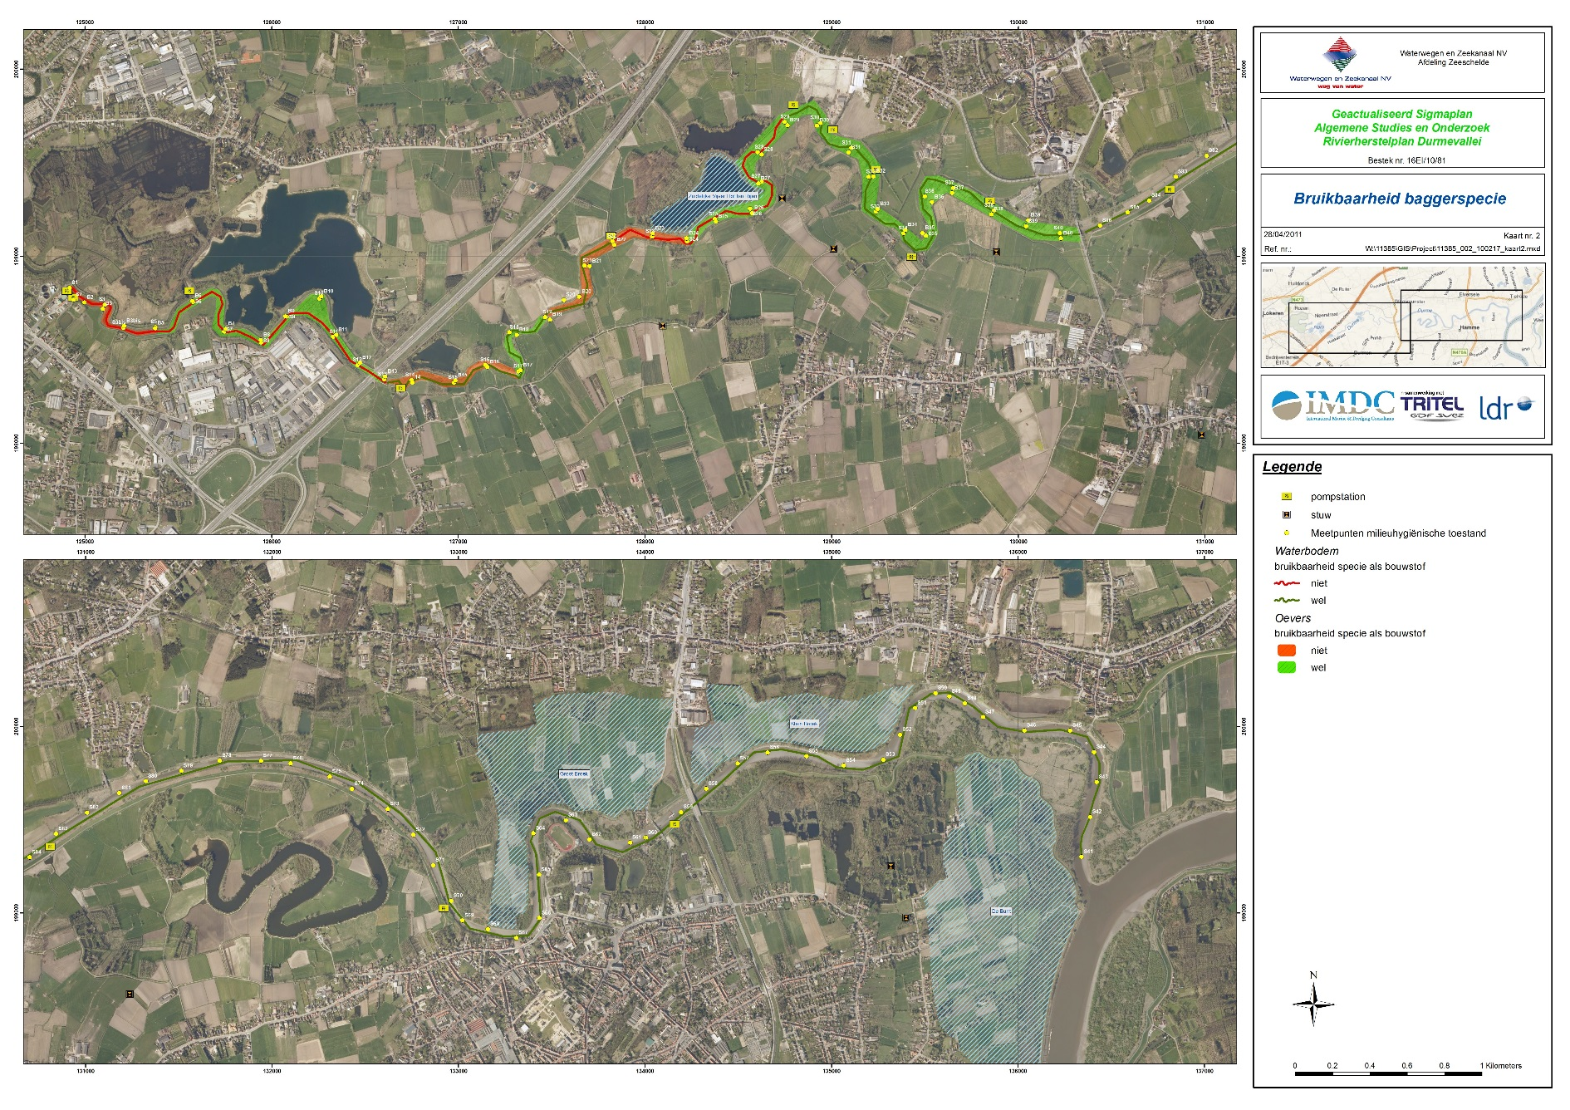

**Figure 9: Map indicating exceedance of quality criteria for use of the sediment as building material, both in the river bottom (red line) and the slopes (orange area)**

Contamination data from the survey shows local exceedance of acceptable Zn, total PCB, Cd, Cr III, Cu, Benzo(a)pyrene and mineral oil concentrations for free use of dredged material. According to the sample results, for all the material a VLAREMA certificate is however obtainable for the use of the dredged material as secondary raw material if the leachability criteria are met.

As contamination concerns different heavy metals as well as total PCB, Benzo(a)pyrene and mineral oil, contamination parameters are very diverse, and the complexity of the treatment procedure(s) very high. The setup of a mobile treatment plant, one of the main tasks of the contractor, is critical for the success of this pilot project within USAR. The contractor must therefore propose a dredging strategy as well as a treatment procedure in order to obtain the VLAREMA certificate and to fulfil the environmental requirement of minimal transport.

**5.4 Dike construction: lessons learned**

A few kilometres upstream from the confluence of the Durme and the Scheldt river a number of comparable flood control areas have been developed over the last years. One of these projects concerns the Vlassenbroek polder. Part of this polder is transformed into a tidal area with a controlled, reduced tide, whereas the other part will only flood when extreme storm surges occur (Van Nederkassel et al., 2014; Van Zele et al., 2014; Van Nederkassel et al., 2015, Quaeyhaegens, 2017, Quaeyhaegens et al., 2017). First investigations have been made with regard to the re-use of dredged material within the dike core. A number of treatment scenarios have been examined in order to determine the dosage of additives to obtain the required geotechnical properties (stability, permeability) as the same problems with too large amounts of fines were detected here.

However the dredging techniques in the Vlassenbroek project were completely different as the ones required or feasible in the upstream part of the Durme, as the dredging works were carried out in the river Scheldt and the central part of the Durme, making use of barges. The contractor will need to propose an adopted procedure with smaller scale dredging techniques combined with an adequate treatment technique (**Figure 10**) in order to be able to incorporate a maximum amount of dredged material into the ring dike core.

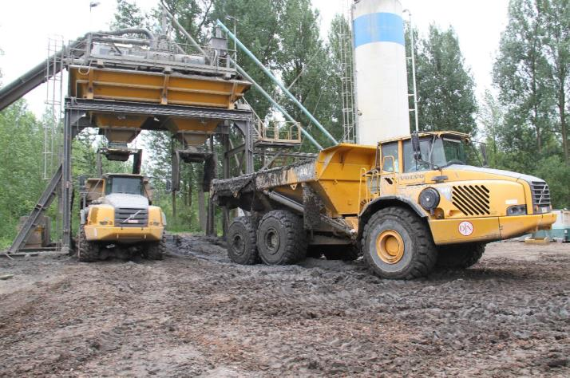

**Figure 10: Example of a mobile treatment plant (Vlassenbroek)**

The net volume of core material to be incorporated in the ring dike is 160 000 m³, while a dredging volume of 260 000m³ is foreseen. This leaves the possibility to reduce the volume of the dredged material by dewatering and treatment before re-use. In order to give the contractor all the necessary elements to be able to determine the best combination of dredging and treatment techniques, a sounding and sampling survey was planned before the publication of the tender.

1. **CONCLUSIONS**

In the framework of the Sigmaplan, which aims at reducing flood risk and increasing the ecological value along the Scheldt estuary, the Flemish waterway manager De Vlaamse Waterweg is executing the Durme Valley River Restoration Plan. The restoration plan wants to revitalize the main functions of the river, i.e. drainage of the surrounding areas, evacuation of flood water, navigation, and nature. While the downstream and central part of this plan are already executed, execution of the upstream part is scheduled for 2018.

In the project the focal point is the re-use of dredged material from the tidal Durme for the renovation of the historical flood control area ‘Potpolder IV’ situated along the river. This renovation involves the construction of a new ring dike with a length of about 3600 m, and the conversion of the existing dike along the river into an overflow dike over a length of approx. 2300 m. The project aims at a 100% re-use of the dredged material. The conditions to dredge are challenging: a small draft, a limited tidal window, and long transport distances. Moreover the nature of the dredged material does not always allow for a direct re-use, neither from a geotechnical nor an environmental point of view. Hence the material will have to be treated.

The paper discussed some possible dredging and treatment techniques. Re-use will be evaluated based on environmental and geotechnical criteria. Dredging strategy and mobile treatment plant setup will be organized in order to obtain the VLAREMA certificate and to fulfil environmental requirements of minimal transport. However, ultimately the choice of techniques (and responsibility) will lie with the contractor (tender to be published at the time of writing).

After successful execution, the Durme river will once again be a well-functioning river, where nature, navigation, and flood protection all have its place.

1. **REFERENCES**

Adams R., Verhaegen K., De Smedt P., Quaeyhaegens H. (2013) The Durme Valley River Restoration Plan, European River Restoration Conference, September 2013, Vienna

Adams R. et al. (2015). Rivierherstelplan Durmevallei (The Durme valley river restoration plan). IMDC RA13030. Waterwegen & Zeekanaal NV.

Quaeyhaegens H. (2017) How beneficial sediment reuse contributes to improve flood defense in Flanders, Belgium, CEDA Days, Rotterdam November 2017

Quaeyhaegens H., Ratinckx P., Van Rompaey M. and Boone C. (2017) Renovation of a Controlled Flood Area in the Scheldt Estuary using dredged material from the Durme river. CEDA Dredging Days 2017

Ratinckx P., Van Rompaey M., Boone C. and Quaeyhaegens H. (2017) Renovation of a flood area in the Scheldt estuary using dredged material from the Durme river SedNet Genova 2017

Santermans J., Adams R. (2015). Baggertechnieken fase 3 (Dredging techniques phase 3). IMDC NO15326. Waterwegen & Zeekanaal NV.

Van Nederkassel J., Van Zele S., Van Renterghem B., Vermeersch T., Quaeyhaegens H. (2014). The use of engineered sediments for the construction of a compartment dike in the controlled flooding area of Vlassenbroek (Belgium), Proceedings of the South Baltic Conference Dredged Materials in Dike Construction, Rostock, Germany, 87-95.

Van Nederkassel J., Van Zele S., Van Renterghem B., Vermeersch T., Quaeyhaegens H. (2015). The use of engineered sediments for dyke construction in the flood control area of Vlassenbroek. Terra et Aqua, Number 138, 5-16.

Van Zele S., Pallemans I., van Nederkassel J., Vermeersch T., Quaeyhaegens H. (2014). L’emploi de sédiments traités pour la construction d’une digue de compartimentation (Belgique), XIIIièmes Journées Nationales Génie Côtier – Génie Civil, Dunkerque, France, 1063-1076.

1. De Vlaamse Waterweg nv, Lange Kievitstraat 111-113, BE-2018 Antwerp
2. International and Marine Dredging Consultants NV, Van Immerseelstraat 66, BE-2018 Antwerp
3. Tractebel Engineering NV, Kortrijksesteenweg, 1144 A, BE-9051 Ghent