New Guidance on Applying Working with Nature

to Navigation Infrastructure Projects

**by**

*Victor S Magar[1], Kirsten Wolfstein[2], Juan Savioli[3], Ellen Johnck[4], Sim Turf[5],*

*Johny Van Acker[6], Paul Scherrer[7], Daan Rijks[8], Lauren Dunkin[9],*

*Danielle Amber[10], Pradeep Mugunthan[11]*

**ABSTRACT**

PIANC’s Work Group (WG) 176 on Guidance on Applying Working with Nature to Navigation Infrastructure Projects, was tasked by PIANC to prepare guidance that raises awareness of natural ecosystems, inspires the navigation infrastructure community to embrace natural systems design, and promotes expanded acceptance of the Working with Nature (WwN) approach by providing a selection of case studies to illustrate how WwN applies to navigation infrastructure projects, identifying associated tools, steps, and practices.

**INTRODUCTION**

WwN is an integrated approach that pursues win-win solutions for navigation infrastructure projects and the environment through careful consideration of natural processes, ecosystem impacts, stakeholder engagement and strategies to maximize opportunities for navigation and nature. Before being implemented, most maritime infrastructure projects must undergo extensive environmental and cultural impact evaluations demonstrating avoidance, minimization, or mitigation of impacts. WwN goes beyond impact avoidance or mitigation and looks for opportunities to integrate nature into project designs, thus creating added value for the project and the environment. As with most contemporary decision-making processes, the WwN philosophy combines social, environmental, and economic considerations into decision making, providing an integrated approach to project development and management. WwN offers an opportunity to design projects with greater holistic integration within the natural environment to secure timely authorizations from regulators.

There are numerous ways in which WwN can be implemented, from altering the surface or texture of submerged structures and thus creating or expanding aquatic habitats, to using natural systems such as islands, marshlands and mangroves, to protecting nearshore environments from severe storm events. The thoughtful implementation of WwN should be aligned with nature, while helping project proponents and environmental stakeholders achieve long-term infrastructure and environmental goals (PIANC 2008, 2011). This Guide for Applying Working with Nature to Navigation Infrastructure Projects discusses WwN in the context of navigation infrastructure, specifically, integrating natural systems and engineering.

For many of those involved with the development and design of waterborne transport infrastructure (e.g., environmental scientists, engineers, project owners and decision makers), WwN is a relatively new paradigm. WwN aims to maximize opportunities to work with natural processes to deliver environmental outcomes that go beyond merely avoiding or compensating for environmental impacts.

While WwN can be contemplated during all phases of a project, it should ideally be considered early in the development of navigation infrastructure projects, when flexibility is maximal. By maintaining a determined and proactive approach from a project’s conception through to its completion, opportunities can be maximized and importantly, frustrations, delays, and unnecessary costs can be reduced.

WwN is fundamentally a philosophy determining the way a navigation infrastructure project is developed. It also involves design and project planning, project implementation, ecosystem and performance monitoring, and adaptive management. The adaptive management component recognizes that navigation projects rely upon learning and adaptation to optimize project outcomes, including reducing energy use and protecting the environment.

WwN requires a subtle but important evolution in the project development approach, by moving beyond the conventional approach of minimizing ecological harm to focus on two new goals; aligning project objectives with existing ecosystem functions and identifying win-win solutions that optimize ecosystem, social, and economic benefits.

As economic growth translates into a global increase in trade and the associated need for new and more efficient waterborne transportation infrastructure persists, the knowledge and experience gained from past successes and failures provide a fresh perspective on infrastructure developments. Adhering to national and international environmental legislation requires an understanding of the impact of infrastructure on ecosystems; non-governmental organizations (NGOs), stakeholders, financial institutes and local communities also demand such awareness. Despite significant progress made in recent years, current approaches to designing and constructing infrastructure typically result in efforts to mitigate for environmental loss. Such approaches are not sustainable.

The issue of sustainability is even more pertinent when we consider that world population and economic growth requires increased infrastructure expansion and upscaling, which places continuous and rising pressures on the natural environment. Environmental challenges ranging from local habitat loss, to the transformation of regional ecosystems, to global climate change, require creative solutions that develop infrastructure in the context of natural ecosystems, so that both may be managed effectively.

WwN thinking can inform the delivery of better environmental protections and enhancements while promoting economic development, reducing delays, and leveraging opportunities to provide local communities with highly sought amenity areas, recreational resources and improved landscape habitats.

**WwN APPROACH**

WwN offers a framework to align new construction, or to rehabilitate existing infrastructure, with natural processes. This approach serves to:

1. enhance ecosystem viability and resilience
2. minimise negative anthropogenic impacts to the environment.

A holistic understanding of ecosystem structures and processes makes it possible to minimise ecosystem degradation and enhance ecosystem functions on a local, regional or watershed scale. Table 1 identifies the environmental, social, and economic benefits that different interest groups could derive from the WwN approach.

***Relevance to Navigation Infrastructure***

For navigation infrastructure projects, WwN addresses concerns such as river and coastal channelization, dredging and dredged sediment management and management of sedimentary environments, including wetlands, coastal dunes or beaches and barrier islands. WwN can help to limit or offset habitat loss associated with infrastructure development or to design projects to align navigation infrastructure with natural processes in sedimentary environments. In some cases, such alignments can help minimise continuous maintenance dredging requirements, particularly in hydrodynamic environments subject to severe weather events.

Fundamentally, all projects must work with nature to some extent. WwN strategies can reduce energy associated with construction or maintenance (thus providing an opportunity to reduce greenhouse gas emissions), increase habitat functionality and otherwise enhance the short- and long-term delivery of ecosystem services associated with project requirements. Often, there is no single WwN solution for navigation and waterborne infrastructure projects, but rather a range of options with different degrees of environmental enhancement.

**Table 1. Project, environmental, and community benefits associated with WwN**

|  |  |  |  |
| --- | --- | --- | --- |
| Opportunity | Project Proponent | Environmental Interests  (Regulators & NGOs) | Community Interests |
| Environmental | Better environmental integration by avoiding or reducing environmental impacts during design, and reducing mitigation obligations to residual impacts.  Improved environment that provides additional ecological services.  Improved economics through better understanding and management of the long term environmental effects. | Environmental improvements and increased services.  Better understanding of project impacts on the environment and how to leverage the project to improve the environment. | Improvement of the natural environment.  Potential for creation of new recreational features linked to the environment. |
| Social | Better community acceptance of projects. | Possible identification of Win-Win opportunities for stakeholders.  Provide better engagement with regulatory authorities, NGOs, the public, and other stakeholders. | Create and identify win-win opportunities.  Greater acceptance of port and navigation projects. Less potential for public obstruction if the community understands the public benefits of the project, and how the project protects and possibly enhances environmental features.  Better and more engagement of stakeholders, and, through this, improved social cohesion.  Better understanding of community interests, leading to better integration of community goals. More active community engagement. |
| Economics | Reduced risk of project interruptions to protect the environment.  Environmental benefits can support a wide range of funding opportunities.  Potentially lowered costs, especially during construction and maintenance.  More streamlined permitting / approval. | Potential cost reductions through accelerated permitting and regulatory approvals, avoidance of unintended environmental impacts, greater public acceptance.  Potential for funding. | Streamlined construction through community involvement.  Aligned community and port / navigation interest, leading to more efficient design.  Long-term economic gains through improved Ecosystem Services and development of new business opportunities. |

WwN objectives are region-specific, site-specific, and project-specific with respect to hydrologic, ecological, economic, and social conditions. Project objectives should be defined in terms of economic benefits and in terms of the ecosystem services that they provide. Those services can be compared to lost services associated with the project work or implementation of the work. Thus, project objectives not only focus on minimising environmental and ecological harm, including environmental impacts associated with construction or with the completed project, but also on preserving or establishing a more natural environment, enhancing habitat functions where possible and improving aesthetics.

***WwN Framework***

The basic steps of WwN, listed below, are illustrated in Figure 1, and include:

Step 1. *Establish Project Needs and Objectives*. Define desired goals and objectives, evaluate alternative actions and select strategies that are aligned with nature.

Step 2. *Understand the Environment*. Understand natural forces and opportunities to work with nature.

Step 3. *Engage Stakeholders*. The WwN approach supports the United Nations Development Program (UNDP) sustainability goals; to achieve economic growth, social development and environmental sustainability. Stakeholder engagement is essential to achieving these goals.

Step 4. *Project Design*. Prepare initial project proposal and design to benefit navigation and nature. Identify design opportunities to work with nature and explicitly demonstrate how WwN is incorporated into the project design.

Step 5. *Build and Implement*. Implement the WwN design. Implementation also can benefit from the WwN philosophy, to minimise unintended consequences to the environment during construction.

Step 6. *Monitor, Evaluate and Adapt*. Monitoring is a continuous process executed during multiple project phases. Similarly, WwN is a continuous process that requires monitoring and adaptation through corrective actions for continuous improvement.

To allow for future uncertainties, WwN requires flexible decision making that can be refined as outcomes from current and future projects are better understood. WwN involves developing and implementing a management plan that defines the project goals, periodically reviews progress towards those goals and implements corrective actions (and refines the plan) as needed in response to the outcomes of environmental monitoring.

WwN encourages consideration of site specific ecosystem characteristics during the project design phase, to achieve project objectives for the development, expansion or growth of ports and navigable waterways. Ideally, WwN requires development of a fully integrated approach with input in to the development of project objectives, and before design begins. While it is possible to implement WwN at virtually all phases of a project, incorporating WwN applications during conception, design and early implementation, provides the most promising opportunities to affect positive outcomes for the environment. Greater effort is generally needed to introduce WwN concepts later in the design process, and those efforts may not be as effective as when WwN is introduced during project initiation.

***Content of WG176 Guide on WwN***

The Guide for Applying Working with Nature to Navigation Infrastructure Projects is organized as follows:

Chapter 1, *Introduction*, introduces the WwN vision, and identifies the intended audience of the report, and provides considerations for economies in transition and developing countries.

Chapter 2, *Background*, provides background information on the WwN approach. The overall framework is introduced, along with beneficiaries of the WwN approach and potential challenges that project owners may face when implementing WwN—by recognizing opportunities and challenges, the hope is that project owners can proactively pursue WwN opportunities for their projects.

Chapter 3, *Context*, describes the context of when and where WwN may be implemented for port and navigation projects. Ports, waterways, and shoreline developments have traditionally relied on conventional infrastructure methods using dredging, steel, concrete or stone for armouring and shoreline protection. WwN recognizes the opportunity to proactively integrate nature into large infrastructure projects to protect or improve natural habitat.

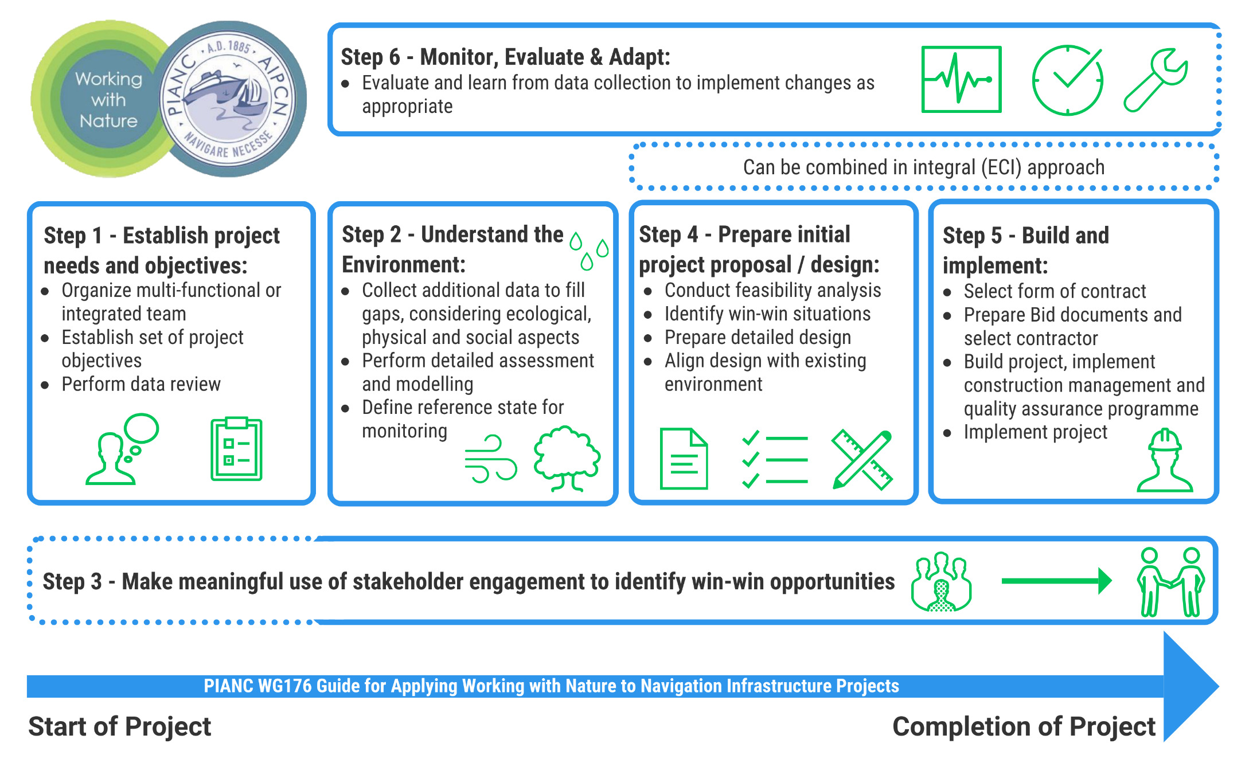

**Figure 1. The Working with Nature Framework**

Chapter 4, *WwN Framework*, describes the WwN framework, outlining six steps identified in the WwN process, from understanding the environment to developing WwN approaches, and from public engagement to design, implementation, and monitoring. Each step is explained in the context of WwN, and how WwN can and should influence project visions and project management approaches.

Section 5, *Working with Nature Case Studies*, provides 12 independent case studies, providing examples of WwN. Each case study is outlined and presented in accordance with the six-step WwN process defined in Section 4. The 12 case studies are an integral component of this Guide. The case studies illustrate the variety of ways that WwN can be integrated into infrastructure projects to protect and enhance nature. Examples include:

* Creation of wetlands and new habitat as part of large infrastructure projects
* Strategic dredged sediment in-water placement to create a variety of new in-water habitats
* Stabilization and upland placement as fill to create land for port expansion
* In-river placement of sediment to promote the formation of islands that promote natural and targeted sediment accumulation, create new island habitats, and reduce sedimentation in the navigation channel by increasing river velocities
* Leveraging of a new infrastructure development (e.g., tunnel construction across a waterway) to develop new shoreline habitat and recreation areas, including wetlands, beaches, and parks

Each example reflects the cooperation among project owners (e.g., ports), governmental organizations, nature-based NGOs, and the public to promote sustainable alternatives that restore or create beneficial ecological habitat, improve dredge management alternatives (particularly through beneficial sediment use), reduce energy consumption, and improve stakeholder engagement.

**REFERENCES**

Bridges, T. S., Lillycrop, J., Fredette, T., Suedel, B., Banks, C. J., Russo, E. (2014). Engineering With Nature for Sustainable Water Resources Infrastructure. Technical article for the 33dd PIANC world congress.

Bridges, TS, PW Wagner, KA Burks-Copes, ME Bates, ZA Collier, CJ Fischenich, JZ Gailani, LD Leuck, CD Piercy, JD Rosati, EJ Russo, DJ Shafer, BC Suedel, EA Vuxton, and TV Wamsley. (2015) Use of Natural and Nature-Based Features (NNBF) for Coastal Resilience. Engineer Research and Development Center (ERDC). Vicksburg, MS. ERDC SR-15-1.

Burdon, D., Atkins, J.P. & Bhatia, N., 2011. Ecosystem services and societal benefits provided by estuarine saltmarsh. Report to ABP & EA, December 2011. (Report No. SBB338-F1-2011).

CEDA (2015). Position Paper – Integrating adaptive environmental management into dredging projects - March 2015

De Vriend, H.-J., Van Koningsveld, M. (2012). Building with Nature: Thinking, acting and interacting differently. Eco Shape, Building with Nature, Dordrecht, the Netherlands.

European Commission (1992). Council Directive 92/43/EEC of 21 May 1992 on the conservation of natural habitats and of wild fauna and flora. http://ec.europa.eu/environment/nature/legislation/habitatsdirective/index_en.htm

MA (2005). Millennium Ecosystem Assessment – Ecosystems and Human Well-being. Synthèses. http://www.millenniumassessment.org/documents/document.356.aspx.pdf.

PIANC 2011. PIANC Position Paper ‘Working with Nature’. Published October 2008; Revised January 2011. Available at http://www.pianc.org/workingwithnature.php.

1. Ramboll, Chicago IL, USA
2. Hamburg Port Authority, Hamburg, Germany
3. DHI Water & Environment, Malaysia
4. Ellen Johnck Consulting, USA
5. Flemish Department of Mobility and Public Works, Belgium
6. De Vlaamse Waterweg NV, Afdeling Bovenschelde, Belgium
7. Ministry of Ecology, Energy, Development, France
8. Boskalis, The Netherlands
9. USACE-ERDC, Vicksburg MS, USA
10. Ramboll, Ann Arbor MI, USA
11. FourPeaks, Chicago IL, USA