**A New PIANC Standard of Practice for Managing Environmental Risks of Navigation Infrastructure Projects**

*by*

Burton C. Suedel1*, David W. Moore1, Capt. Kevin Allen2, Rebecca Gardner3, Kevin Kane4, John Lally5, Miran Vanwonterghem6, Amy Parry7, and Todd S. Bridges8

# Abstract

The World Association for Waterborne Transport Infrastructure (PIANC) Environmental Commission Working Group 175 (WG 175) was tasked with developing a practical guide derived from existing methods and approaches for informing decision makers managing environmental risk associated with waterborne transport infrastructure projects. The risk management methodology builds on existing PIANC and other reports and show decision makers (i.e., project managers and policy makers) how to transition from risk assessment to risk management. WG 175 is working closely with other WGs related to Working with Nature (WwN; WG 176), ecosystem services (WG 195), and climate change adaptation (WG 178) to ensure consistency among the WGs. This process provides a practical methodology for managing the likely environmental impacts of project components in the context of natural change in time (short to long term), space (e.g., floods, storms, near field/far field), and other social and recreational activities (e.g., fishing and tourism). The methodology would ensure that risk management alternatives will have the ability to compensate or counteract adverse environmental impacts caused by the project.

The guidance incorporates aspects of international best practice related to managing project risks that consider multiple processes (e.g., physical, chemical, biological, socioeconomic, etc.) operating over broad spatial and temporal scales. Large uncertainties related to these processes can prevent clear projections about the future performance of associated risk management actions. The management of risk involves both large economic and environmental costs, and is further complicated by the diverse range of policies, perspectives, risk attitudes and personal values that drive risk management decision making. The developed risk management guide and supporting methodologies provide the foundation for a decision support system for environmental risk management.

The primary objective of the report is to provide technical information and develop a methodology for decision makers to manage risk associated with waterborne infrastructure projects by drawing from existing approaches and best practices worldwide. It builds on the PIANC WG 10 report “Environmental Risk Assessment of Dredging and Disposal Operations” (PIANC 2006) and show decision makers how to transition from risk assessment to risk management. The report reflects the close collaboration between ongoing work with other PIANC WGs on Working with Nature (PIANC 2008), and recently formed PIANC WGs on ecosystem services and climate change adaptation to ensure consistency among WG reports. The developed risk management framework and supporting methodologies will provide the foundation for a decision support system for environmental risk management.

Previous PIANC EnviCom Working Groups have developed procedures addressing various aspects of environmental risk assessment for dredging and dredged material disposal, providing a scientific basis for making decisions based on environmental risk assessment data. However, these reports did not address methodologies for managing environmental risks. This report has been developed to fill this gap providing a guideline derived from existing methods and approaches for decision-makers managing environmental risk associated with waterborne navigation infrastructure projects, and aims to bring these practical considerations together in a usable, ERM framework.

This report presents a practical and structured management process through which actions for reducing environmental risks are identified, evaluated, selected, and implemented. The process includes an approach and methods for comparing and evaluating alternative risk management actions to inform decision-making. The approach is compatible with the WwN concept taking into account existing methods for managing environmental risks while providing an open, deliberative, and transparent decision-making process. This guideline:

* defines the concepts of risk, risk assessment, and risk management;
* presents an integrated approach to risk‐based management that is practical and implementable;
* addresses uncertainty associated with short-term event-based related to infrastructure operations, longer term risks (e.g., climate change), residual risk, and resiliency of natural features;
* reviews available methods that support risk-informed decision-making so that the uncertainties associated with managing environmental risk are recognized and addressed;
* presents risk management as a process for achieving efficient and effective risk reduction;
* Discusses the role of sustainability and life-cycle analysis in the context of risk management, and;
* incorporates adaptive management principles and practices.

The key components of the framework (Figure 1) are:

* understanding;
* assessing;
* deciding;
* managing and monitoring; and
* communication.

The first step in the ERM framework is project formulation, which functions to scope the project, develop project alternatives, demonstrate positive environmental outcomes, and set the stage for early stakeholder engagement. Project feasibility follows to help justify a selected alternative that achieves project goals while providing the best overall benefit at a reasonable cost, and includes the evaluations and assessments supporting the chosen risk management strategy. Next, the project execution phase encompasses the engineering design, construction, delivery and monitoring of the navigation infrastructure project elements, and will require ongoing communications and stakeholder participation to be successful. Once the preferred project alternative is selected, the detailed engineering phase will generate new data, design considerations, and constraints that will affect ERM decisions.

A key to a successful project is early consideration of ERM, leading to more efficient permitting and approval processes, as regulators are afforded a greater appreciation and confidence in project delivery and management, and are less likely to revert to a precautionary approach. As Figure 1 illustrates, the ERM framework incorporates early consideration of potential environmental risk, well before the finalization of the project business case and detailed design of potential project alternatives. This differs substantially from a project where ERM is considered late in the project, typically during the formal environmental approvals and permitting stage, when business cases have been finalized, financial assurance criteria have already been established, planning and detailed design have been undertaken, and there are limited opportunities to revise or improve upon project alternatives. To remain effective, ERM should be a living process where iteration is possible in cases where additional data or information can be included, as necessary to better inform the ERM process. As indicated in the center of the figure, stakeholder engagement and adaptive management are core tenants of the framework and underpin the transition from environmental risk assessment to environmental risk management.

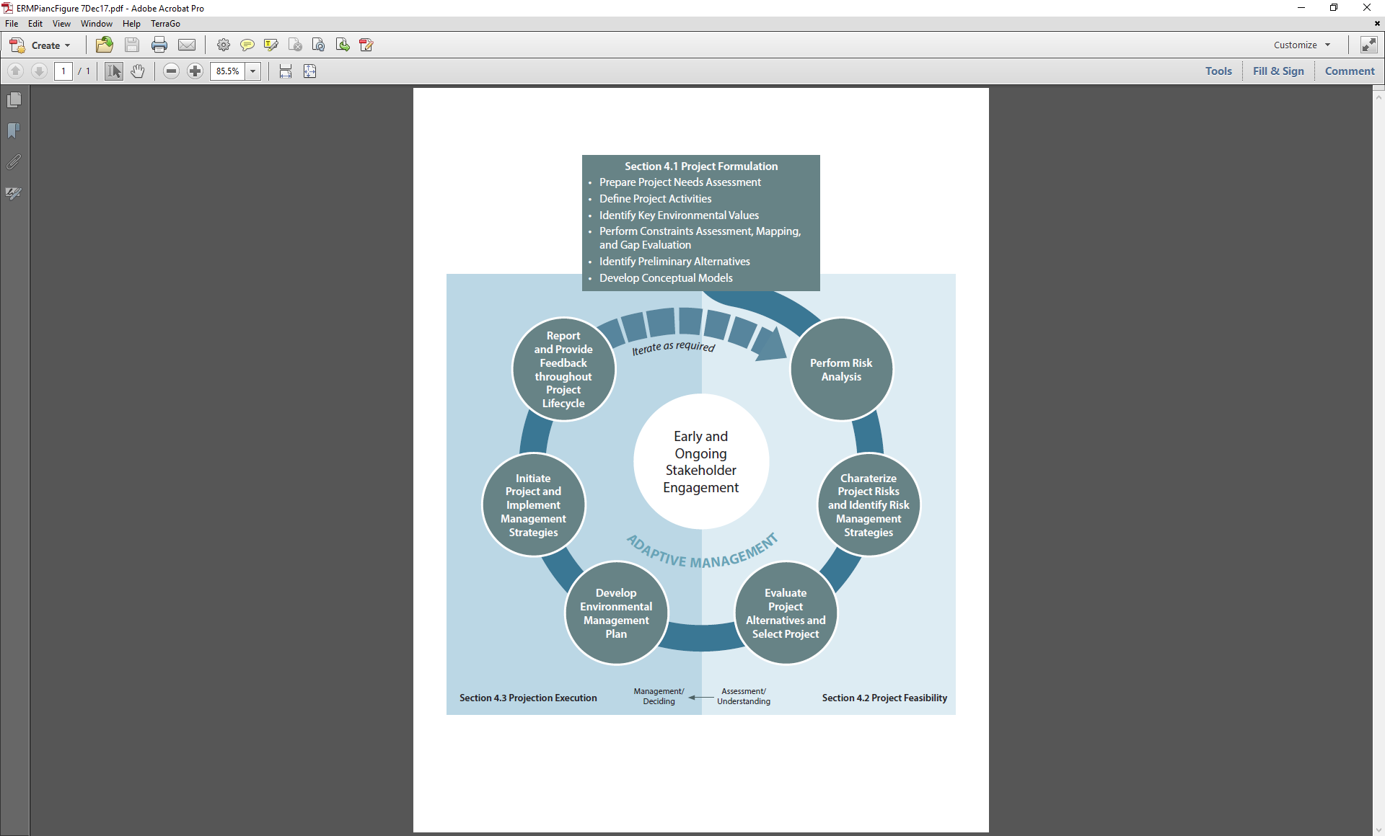

**Figure 1. An Environmental Risk Management Framework for Navigation Infrastructure Projects.**

In developing the approach, elements associated with expert knowledge of the system, including an understanding of the ecosystem, project components and their different construction techniques, as well as stakeholder communication, are included as a means of developing a practical and adaptable risk management process. Descriptions of one or more case studies communicating risk management principles and best-practices are also provided to illustrate how the approach can be implemented in practice.