**Restoring forests for water related and other ecosystem services in the Panama Canal Watershed**

Jefferson S. Hall1, Robert F. Stallard1,2, Jason Regina3, Jonathan Thompson4, Josh S. Plisinski4, and Fred L. Ogden3

1 Smithsonian Tropical Research Institute, Panama

2 United States Geological Survey, U.S.A.

3 University of Wyoming, U.S.A.

4 Harvard Forest, U.S.A.

One of the biggest development challenges faced in the 21st century is access to abundant fresh water. While it is often assumed that forests regulate the hydrological cycle in the moist tropics by enhancing dry season stream flow, the evidence to support this has been limited and the ecosystem service itself is in dispute. Nevertheless, policy makers and practitioners call for reforestation in order to restore this ecosystem function, often referred to as the sponge effect. The Agua Salud Project was established in the moist steepland forests of the Panama Canal Watershed in 2008 to study the ecosystem services provided by seasonal tropical forests and how they change with land use and climate change. Nine watersheds that include mature forest, pasture, and different active and passive reforestation treatments have been monitored constantly since 2008 to both test forests ability to regulate the hydrological cycle and how these different land management techniques can restore this ecosystem function. All reforestation treatments were initiated in 2008. At the same time we monitored tree growth in forests and plantations as well as biomass of grasses in pastures.

During the 2013 dry season, the first pronounced dry season since the instrumentation of weirs at our Agua Salud site, we recorded a pronounced difference in stream flow between our forested and deforested watersheds and thus confirmed the sponge effect at our site (Figure 1).

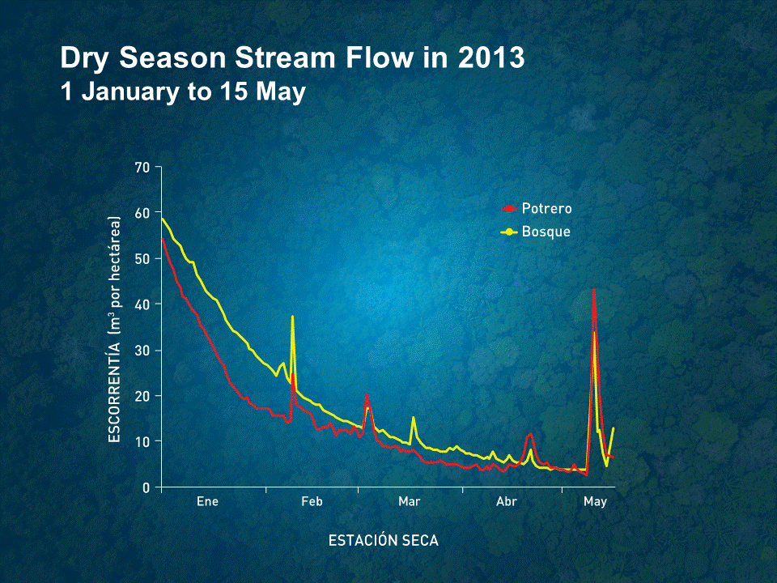

Figure 1. Dry season stream flow in the Agua Salud Project experimental watersheds during the dry season of 2013 (Potrero = pasture; Bosque = forest).

In December 2010 we captured the flood of record in the Panama Canal Watershed and recorded markedly lower stream flow in our forested watershed as compared to our deforested watershed (Figure 2 from Ogden et al. 2013). The catchments at our Agua Salud site have the same soils and geology as the upper Chagres watershed within Chagres National Park. Thus if we do a thought experiment and deforest the park we can provide a first approximation of the value of the forest sponge.

Previous work published from our Agua Salud site suggests that we can start to see the effects of restoration of the sponge effect within the first several years of reforestation. We will discuss the potential to restore the forest sponge as well as the ramifications of projected changes in land use in Central Panama in view of the forest sponge.

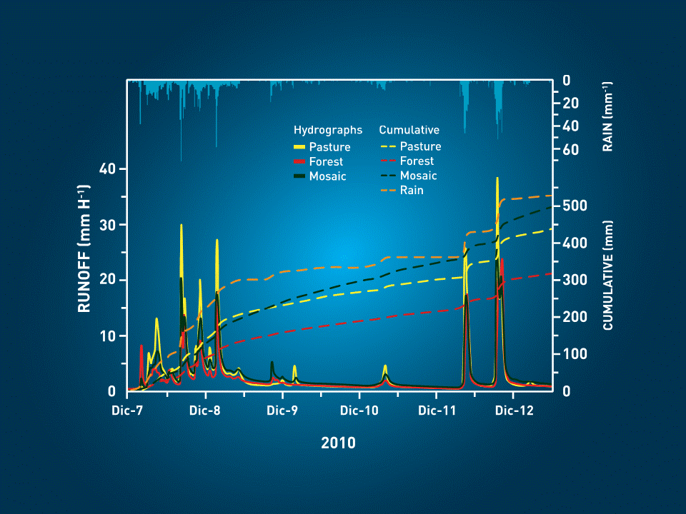

Figure 2. Cumulative stream flow over five day period of the storm of record in the Panama Canal Watershed in the Agua Salud Project experimental watersheds from December 7 to 12 2010 (from Ogden et al. 2013).